

Moderna Database Project

MIS 531: Enterprise Database Management

**By Anirudh Sharma, University of Arizona**

Table of Contents

**Chapter 1: Requirements Analysis 3**

**Chapter 2: ER Diagram and Data Dictionary5**

Entity-Relationship Diagram (Full)5

Entity-Relationship Diagram (Employees)6

Entity-Relationship Diagram (Projects)7

Entity-Relationship Diagram (Orders)8

Entity-Relationship Diagram (Purchases)9

Data Dictionary10

**Chapter 3: Normalization16**

**Appendix to Chapter 3: Table Creation Statments20**

**Chapter 4: SQL Queries29**

**Chapter 5: Triggers and Procedures35**

Triggers (3)35

Procedures (1)38

**Chapter 6: User Interface40**

**Chapter 7: Implementation Planxx**

**Appendix A: Lessons Learnedxx**

Chapter 1: Requirements Analysis

Requirements Description:

Moderna wants to keep track of its employees. It tracks their employee ID, name (first and last), date of birth, title, hire date, and which department they work for. Employees also possess skills at varying levels. Each skill has its own ID, description, and certification information. Each employee can be a department head, project manager, researcher, sales representative, HR representative, or none of these. For dept heads and project managers Moderna also tracks their office ID. For researchers, they store the number of papers they have published, which papers they have published, and their highest degree earned. HR representatives are responsible for servicing a particular department, while sales representatives deal with customers.

An employee can occupy an office but doesn’t have to. Each office is its own unique ID, and information is stored on the location (city, state, country), the office head/lead, and the number of employees who work there. Employees can participate in events, each of which has an ID, description, start time, and end time. Events can have a press release to announce them. For each press release, an ID, date, and details are stored. Some employees produce publications. Each publication has an ID, date, a type of technology it covers, and further details.

Research Teams are assigned a level of ability and are made up of one project manager and up to five researchers. Business Teams are formed for a specific goal and are made up of one project manager and up to five sales representatives. Employees can work on either research projects or business projects. All projects have a project ID, title, start date, end date, manager, client, and grant amount. Research projects have a modality, lead researcher, and which phase of the development pipeline they are in, while business projects track expected income. Each project generates a project log to track time spent on the project. Additionally, research projects involve patients suffering from a disease. Moderna wants to know the disease name, id number, infectiousness, when infection occurred, the effectiveness of treatment, and cure rate. They also want to track side effects from treatments and give each an ID, name, rate of occurrence, and level of seriousness while keeping a log of potential causes and treatments for the side effect.

Every employee works in exactly one department, and each department has at least one employee but can have many. Each department has a dept ID, dept head, a location (one building), and a size (number of employees). Departments follow regulations based on where they are located, each of which has an ID, name, date it was implemented, and country where it applies.

Departments make purchases of raw materials from Moderna’s suppliers. Each supplier has an ID, contact number, and name. Each purchase is tracked by its purchase number, and contains information on the purchase date, delivery date, when payment is due, and the cost. Each raw material purchased has an ID and date of manufacture. Each shipment has a unique ID and date, includes raw materials, and is ordered from a storage location (which also has an ID, as well as a maximum capacity and capacity currently being used). Shipment details are maintained, including the date of delivery, quantity, price per unit, and total price of the purchase. The raw materials purchased by departments are used by Moderna’s manufacturing sites to produce products. Each manufacturing site has an ID, location, and contact info (phone number and email).

Moderna’s customers place orders that contain products. For each customer, Moderna maintains information on their ID, name, location, contact info, and how long they have been a customer. Each order has an invoice number, an order date, delivery date, payment due date, and total cost. The product quantity and unit price for products contained within the order are also generated. Products are given a product ID, name, price, and the remaining inventory is tracked. Sometimes a product has up to one promotion associated with it, which includes a promotion ID, name, and description. A single promotion can apply to many products. When products are produced by Moderna’s manufacturing sites, a product production log is generated showing the amounts of raw materials used in production.

Moderna will need two primary user types to have access to the front end of the database: customers and administrators. Customers will use the system to place orders (which will automatically trigger a change in the inventory on the products table) and view their order details. Administrators must have privileges to edit and delete data.

Chapter 2: ER Diagram and Data Dictionary

Entity-Relationship Diagram (Full)

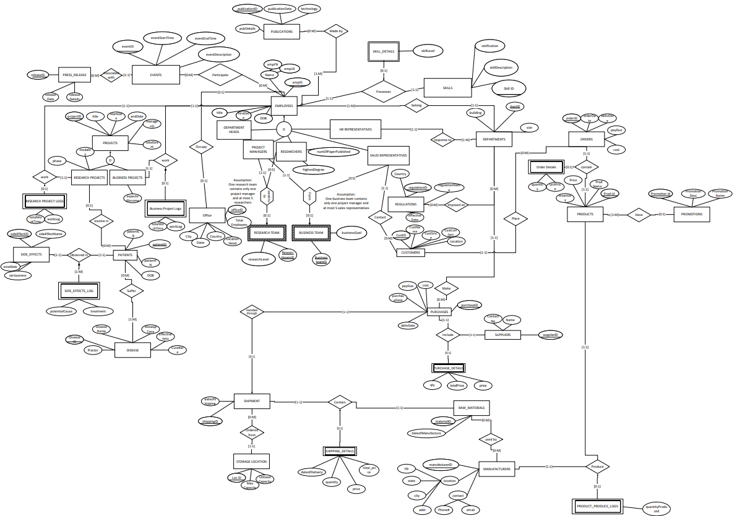

Entity-Relationship Diagram (Employees Focus)

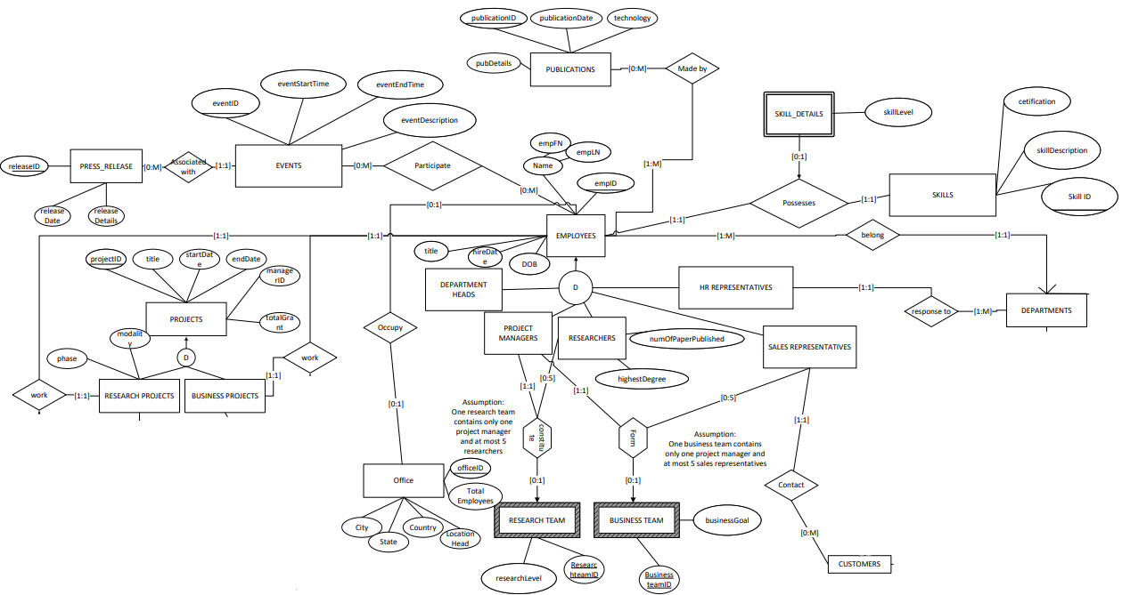

Entity-Relationship Diagram (Projects Focus)

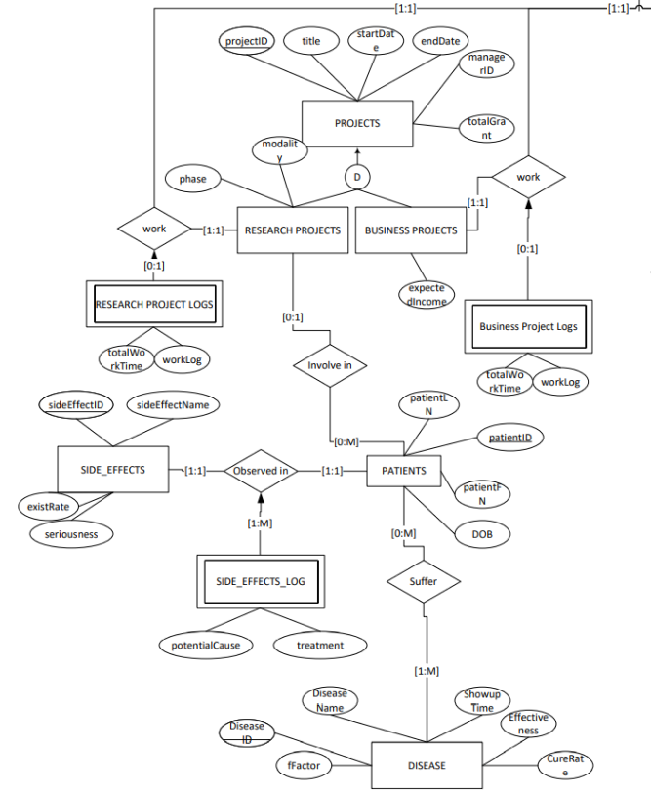

Entity-Relationship Diagram (Orders Focus)

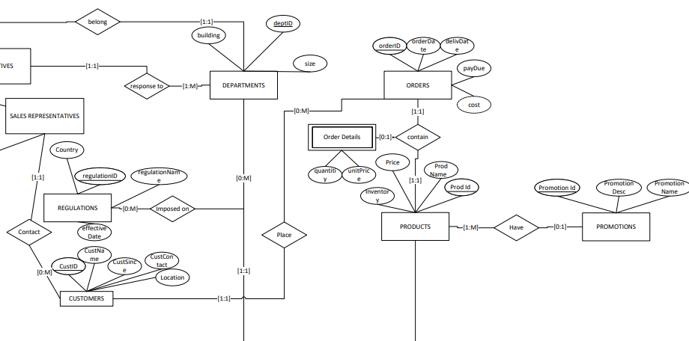

Entity-Relationship Diagram (Purchases Focus)

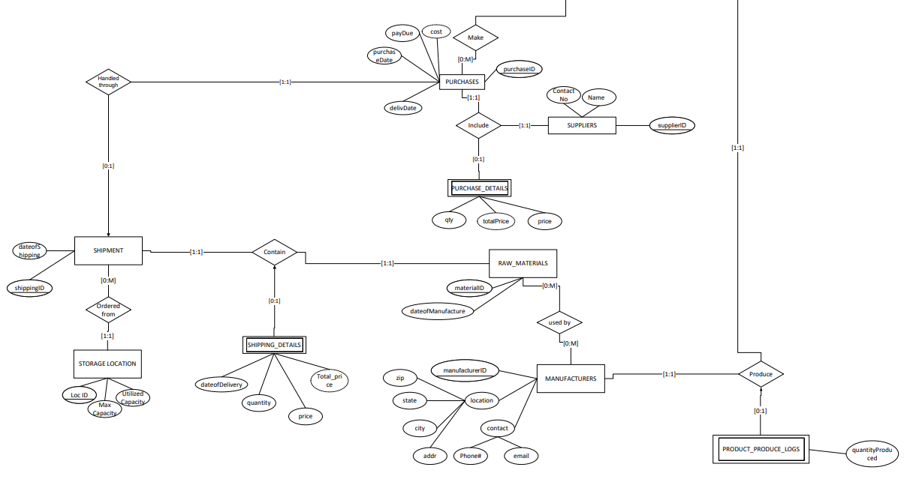

Data Dictionary

|  |  |  |
| --- | --- | --- |
| ***Schema Construct*** | ***Construct Description*** | ***Other Information*** |
| **EMPLOYEES** | Entity Class, to model employees of Moderna |  |
| empID | Employee ID | Identifier |
| empFN | Employee first name | Attribute should not contain NULL values |
| empLN | Employee last name | Attribute should not contain NULL values |
| dateOfBirth | Date of birth |  |
| hireDate | Employee hiring date | Should no more than the date of birth |
| title | Employee working title |  |
| **DEPARTMENT HEADS** | Subclass of EMPLOYEES |  |
| **PROJECT MANAGERS** | Subclass of EMPLOYEES |  |
| **RESEARCHERS** | Subclass of EMPLOYEES |  |
| highestDegree | the highest this employee is holding |  |
| numOfPaperPublished | The number of papers this employee has published |  |
| **HR REPRESENTATIVES** | Subclass of EMPLOYEES |  |
| **SALES REPRESENTATIVES** | Subclass of EMPLOYEES, assigned to CUSTOMER |  |
| **RESEARCH TEAM** | Aggregation entity class |  |
| researchteamID | The teamID of the research team | Identifier |
| researchLevel | The research capability of the team | 3 level: Entry, Senior, Lead |
| **BUSINESS TEAM** | Aggregation entity class |  |
| businessteamID | The teamID of the business team | Identifier |
| businesGoal | the goal of this business team |  |
| **PROJECTS** | Entity Class, to model Moderna's projects |  |
| projectID | Project ID | Identifier |
| projectTitle | The title of this Project |  |
| startDate | Project Start date | Should be a valid date |
| endDate | Project end date | No more than begin date |
| totalGrant | The number of funding has been invested in this project |  |
| **RESEARCH PROJECTS** | Subclass of PROJECTS |  |
| modality | Project modality |  |
| phase | Current project phase in the moderna pipeline | Attribute should not contain NULL values |
| **RESEARCH PROJECT LOGS** | Weak Entity, recording the information related to EMPLOYEES |  |
| projectID | Project ID | Identifier |
| empID | Employee ID | Identifier |
| totalWorkTime | Total working time of an employee for a specific project | Should not exceed the maximum working hours |
| workLog | Other information about this work |  |
| **BUSINESS PROJECTS** | Subclass of PROJECTS |  |
| expectedIncome | Expected income Moderna will get from this project | Attribute should not contain NULL values |
| **BUSINESS PROJECT LOGS** | Weak Entity, recording the information related to EMPLOYEES |  |
| projectID | Project ID | Identifier |
| empID | Employee ID | Identifier |
| totalWorkTime | Total working time of an employee for a specific project | Attribute should not contain NULL values |
| workLog | Other information about this work |  |
| **DEPARTMENTS** | Entity Class, to model Moderna's departments |  |
| departmentID | Department ID | Identifier |
| workBuilding | The building that the whole office is placed |  |
| totalNumber | The department size |  |
| **ORDERS** | Entitiy Class, to model Moderna's order for each department |  |
| orderID | Order ID | Identifier |
| orderDate | The date of order is genearated | Attribute should not contain NULL values |
| delivDate | The date of order is delivered | Attribute should not contain NULL values |
| payDue | The time of payment is due | If the paydue date - bill date > 15 days, then order is overdue |
| cost | The total cost of the order | Attribute should not contain NULL values |
| **ORDER DETAILS** | Weak Entity Class |  |
| quantity | Quantity of item ordered | Attribute should not contain negative values |
| unitPrice | Unit Price per item | Attribute should not contain negative values |
| **SUPPLIERS** | Entity Class, to model Moderna's suppliers |  |
| supplierID | Supplier ID | Identifier |
| name | Supplier Name | Attribute should not contain NULL values |
| contactNum | Supplyer Contact Number | Attribute should contain a real phone number or NULL |
| **CUSTOMERS** |  |  |
| custID | Customer ID | Identifier |
| custName | Customer Name |  |
| custSince | Customer Since | Date |
| custContact | Customer Contact | Should be a valid phone number |
| location | Headquarter location | Attribute should contain a real phone number or NULL |
| **PRODUCTS** |  |  |
| prodID | Product ID | Identifier |
| prodName | Product Name |  |
| inventory | Inventory quantity remaining | Attribute should not contain negative values |
| price | Price per unit | Attribute should not contain negative values |
| **OFFICE** | Relates to Employee entity class |  |
| locationID | Location ID | Identifier |
| City |  | Should be a state inside the USA |
| State |  | Should be a city inside the state |
| Country |  | DEFAULT USA |
| totalEmployees | The number of employees assigned the location | Attribute should not contain negative values |
| **STORAGE_LOCATION** | Relates to Employee, Products and Supplier entity class |  |
| locID | Location ID | Identifier |
| maxCapacity | A location's max capacity of storing the drugs | Attribute should not contain negative values |
| utilizedCapacity | The available space to ship/store more drugs or products | Attribute should not contain negative values |
| **PROMOTIONS** | Entity class to store the information about promotion and advertisment campaigns |  |
| promotionID | Promotion ID | Identifier |
| promotionDesc | Promotion description |  |
| promotionName | Promotion Name |  |
| **PATIENTS** | Entity class to store the information about patients involved in research projects |  |
| patientFN | The first name of this patient | Should be credential |
| patientLN | The last name of this patient | Should be credential |
| patientID | The ID of this patient | identifier |
| dateOfBirth | Patient date of birth | Should be credential |
| **EVENTS** | Entity class |  |
| eventID | The company event ID | Identifier |
| eventStartTime | start time of the event |  |
| eventEndTime | End time of the event | Should not be larger than start time |
| eventDescription | description of the event |  |
| **SKILLS** | related to EMPLOYEE |  |
| skillID | skill ID | Identifier |
| skillDescription | description of the skill | Attribute should not contain NULL values |
| cetification | the required certifications for this skill |  |
| **SKILLS_DETAILS** | Weak entity class between Employee and the Skill |  |
| skillLevel | level of the acquired skill | 3 levels: Basic, Profient, Expert |
| **DISEASE** | Entity class to model the diseases Moderna is studying |  |
| diseaseID | Disease ID | Identifier |
| diseaseName | Name of the disease |  |
| rFactor | r factor of infectousness |  |
| showupTime | First time show up |  |
| effectiveness | Morderna's effectiveness against it |  |
| cureRate | Rate of cure | Attribute should not contain negative values |
| **SHIPMENT** | relates to storage_location and shipment details |  |
| shipmentID | Primary Key | Identifier |
| dateofShipping | Date on which shipment was ordered |  |
| dateofDelivery | Date on which the shipment was delivered | The delivery date should be no more than date of shipping |
| **SHIPMENT_DETAILS** | weak entity class linked with shipment and storage_location |  |
| quantity | quantity of raw material ordered in a Shipment | Attribute should not contain negative values |
| price | Price of the Shipment Order | Attribute should not contain negative values |
| total_price | quantity *price - derived attribute | Attribute should not contain negative values |
| **RAW_MATERIAL** | relates to SHIPMENT and SHIPPING DETAILS entity classes |  |
| materialID | Material ID - primary key | Identifier |
| dateofManufacture | Date of Manufacture for the material |  |
| **REGULATIONS** | The details of regulations linked with Departments |  |
| regulationID | Regulation ID | Identifier |
| regulationName | The description of the regulations |  |
| effectDate | When is the regulation effective |  |
| Country | The country in which regulations are put up by the local government |  |
| **SIDE-EFFECT** | relates to Research Projects |  |
| sideeffectID | Side-effect ID | Identifier |
| sideeffectName | The description of the side-effect |  |
| seriousness | How serious is the effect |  |
| existRate | Rate of happening | Attribute should not contain negative values |
| **PUBLICATIONS** | relates with Employees |  |
| publicationID | ID of the publication | Identifier |
| publicationDate | Publication date |  |
| technology | The research area under which the employees made the research |  |
| publicationDetails | includes details of scientists/employees working on publication |  |
| **PRESS_RELEASE** | Entity class to model press release |  |
| pressReleaseID | ID of the press release |  |
| releaseDate | Press dates |  |
| releaseDetails | Other details about this press release. | Composite attribute |
| **SIDE_EFFECTS_LOG** | Weak entity interact with PATIENTS and SIDE_EFFECTS |  |
| potentialCause | Potential reasons that might cause this side affect |  |
| treatment | The treatment this patient is taking |  |
| **PRODUCT_PRODUCE_LOGS** | Weak entity interact with PRODUCT and MANUFACTURES |  |
| quantityProduced | The quantity of the product Produced by the manufacture. | Attribute should not contain negative values |
| **MANUFACTURERS** | Entity class to model the manufactures |  |
| manufacturerID | ID of this manufacturer | Identifier |
| State | The state of this manufacturer | Should be a state inside the USA |
| city | The city of this manufacturer | Should be a city inside State |
| zip | The zip code of this manufacturer | Should be a valid zip code |
| location | The location of this manufacturer | Should be an address |
| phone# | The manufacturer's phone number | Should be a valid phone number |
| email | The manufacturer's email address | Should be a valid email address |
| **PURCHASES** | Entity class to model the purchases from departments |  |
| purchaseID | ID of this Purchase | Identifier |
| purchaseDate | The date this purchase happened |  |
| cost | Total cost of this purchase |  |
| delieverDate | The order delievery date | The deliever date should be no lager than purchase date |
| payDue | The pay due of this purchase | The pay due date shuould be 15 days after purchase date |
| **PURCHASE_DETAILS** | Weak entity class to reocrd details about the purchases |  |
|  |  |  |
|  |  |  |
|  |  |  |
| **RELATIONSHIPS:** |  |  |
| **IS RESPONSIBLE FOR** | Relationship that models HR being responsible for a specific department |  |
| **BELONG TO** | Relationship that models an employee belonging to a department |  |
| **WORK ON** | Relationship that models employees working on a project |  |
| **PLACE** | Relationship that models a department places orders |  |
| **CONTAIN** | Relationship that models an order contains certain products |  |
| **FORM** | Aggregation relationship: one research team contains only one project manager and at most 5 researchers;one business team contains only one project manager and at most 5 sales representatives |  |
| **CONTACT** | Relationship: sales representatives contact customers for placing orders |  |
| **PLACE** | Relationship: Customers place orders |  |
| **INVOLVE IN** | Relationship: Patients get involved in research projects |  |
| **SUFFER** | Relationship: Patients suffered by diseases |  |
| **SUPPLY** | Relationship: Suppliers supply products |  |
| **HAVE** | Relationship: Products can have promotion |  |
| **POSSESSES** | Relationship that models EMPLOYEES Possesses SKILLS |  |
| **PARTICIPATE** | Relationship that models EMPLOYEES Participate EVENTS |  |

Chapter 3: Normalization

We converted the ER diagram into relational schema. We use option A for superclass and subclass conversion. And also use option1 for 1 to many relations. For many to many relations we create an additional table which Represents the Relationship. In Each schema the primary key attribute is underlined. Foreign key is mentioned if any refers to another table. Check/unique constraints are added in necessary cases. We got 51 relational schema after conversion listed below:

BUSINESS_TEAMS(teamID, businessGoal)

BUSINESS_TEAM_SALE_REPRESENTATIVES(teamID, empID)

Foreign Key (teamID) references BUSINESS_TEAMS(teamID)

Foreign Key (empID) references EMPLOYEES(empID)

BUSINESS_TEAM_MANAGERS(teamID, empID)

Foreign Key (teamID) references BUSINESS_TEAMS(teamID)

Foreign Key (empID) references EMPLOYEES(empID)

BUSINESS_PROJECTS(projectID, expectedIncome)

Foreign Key (projectID) references PROJECTS(projectID)

BUSINESS_PROJECT_LOGS(projectID, empID, totalWorkTime, workLog)

Foreign Key (projectID) references PROJECTS(projectID)

Foreign Key (empID) references EMPLOYEES(empID)

CUSTOMERS(CustID, CusName, CustSince, CustContact, Location)

DEPARTMENTS(deptID, building, size)

DEPARTMENT_HEADS(empID)

DEPARTREGULATION(deptID, regulationID)

DISEASE(diseaseID, diseaseName, showupTime, effectiveness, cureRate, fFactor)

EMPLOYEES(empID, worktype, empFN, empLN, dateOfBirth, hireDate, title)

check constraint (hireDate > dateOfBirth)

EMPLOYEES_MAKE_PUBLICATIONS(empID, publicationID)

Foreign Key (empID) references EMPLOYEES(empID)

Foreign Key (publicationID) references PUBLICATIONS(publicationID)

EMPLOYEES_OCCUPY_OFFICES(empID, officeID)

Foreign Key (officeID) references OFFICES(officeID)

Foreign Key (empID) references EMPLOYEES(empID)

EMPLOYEES_PARTICIPATE_EVENTS(empID, eventID)

Foreign Key (empID) references EMPLOYEES(empID)

Foreign Key (eventID) references EVENTS(eventID)

EMPLOYEESWRITEPUB(empID, publicationID)

Foreign Key (publicationID) references PUBLICATIONS(publicationID)

Foreign Key (empID) references EMPLOYEESWRITEPUB(empID)

EMPLOYEES_POSSESS_SKILLS(empID, skillID, skillLevel)

Foreign Key (empID) references EMPLOYEES(empID)

Foreign Key (skillID) references SKILLS(skillID)

EVENTS(eventID, releaseID, eventStartTime, eventEndTime, eventDescription)

HR_REPRESENTATIVES(empID, deptID)

Foreign Key (empID) references EMPLOYEES(empID)

Foreign Key (deptID) references DEPARTMENTS(deptID)

MANUFACTURERS (manufacturerID, location, contactPhone, contactEmail)

OFFICE(officeID, TotalEmployees, city, state, Country)

ORDERS(orderID, orderDate, delivDate, PayDue, cost, CustID)

Foreign key (CustID) references CUSTOMERS

check CONSTRAINT (delivDate >= orderDate)

ORDER_DETAILS(orderID, prodID, quantity, unitPrice)

Foreign key (orderID) references ORDERS

Foreign key (prodID) references PRODUCTS

check CONSTRAINT (quantity > 0)

OVERDUE_ORDERS_LOG(logID, orderID, orderDate, payDate, custID, overdueDays, logDate)

Foreign key (CustID) references CUSTOMERS (CustID)

Foreign key (orderID) references ORDERS (orderID)

PATIENTS(patientID, projectID, patientFN, patientLN, DOB)

Foreign Key (projectID) references RESEARCH_PROJECTS

patients_suffer_from(patientID, diseaseID)

Foreign Key (patientID) references PATIENTS(patientID)

Foreign Key (diseaseID) references DISEASE(diseaseID)

PATIENTSUFFDIS(patientID, DiseaseID)

Foreign Key (patientID) references PATIENTS(patientID)

Foreign Key (DiseaseID) references DISEASE(diseaseID)

PRODUCTS(prodID, prodName, inventory, price, promotionID)

Foreign key (promotionID) references PROMOTIONS(promotionID)

PRODUCT_PRODUCE_LOGS (manufacturerID, prodID, quantityUsed)

Foreign Key (manufacturerID) references MANUFACTURERS (manufacturerID)

Foreign Key (prodID) references PRODUCTS (prodID)

check constraint(quantityProduced >= 0)

PURCHASE_DETAILS (purchaseID, supplierID, price, qty, totalPrice)

Foreign Key (purchaseID) references PURCHASES (purchaseID)

Foreign Key (supplierID) references SUPPLIERS (supplierID)

PURCHASES (purchaseID, purchaseDate, delivDate, payDue, cost)

Foreign key (manufacturerID) references MANUFACTURES

Foreign key (prodID) references PRODUCTS

PRESS_RELEASE(releaseID, eventID, releaseDate, releaseDetails)

Foreign key (eventID) references EVENTS (eventID)

PROMOTIONS(promotionID, promotionDesc, promotionName)

check constraint (enddate >= startdate)

PUBLICATIONS(publicationID, publicationDate, technology, pubDetails)

PROJECTS(projectID, title, startDate, endDate, managerID, totalGrant)

Foreign Key (managerID) references EMPLOYEES (empID)

RESEARCH_PROJECTS(projectID, phase, modality)

Foreign Key (projectID) references PROJECTS (projectID)

REGULATIONS(regulationID, Country, regulationName, effectDate)

Foreign Key (deptID) references DEPARTMENTS (deptID)

Foreign Key (DiseaseID) references DISEASE(DiseaseID)

RESEARCH_PROJECT_LOGS(projectID, empID, totalWorkTime, workLog)

Foreign Key (projectID) references PROJECTS(projectID)

Foreign Key (empID) references EMPLOYEES(empID)

RESEARCHERS(empID, highestDegree, numOfPaperPublished)

Foreign key (empID) references EMPLOYEES (empID)

RESEARCH_TEAMS(teamID, researchLevel)

RESEARCH_TEAM_MANAGERS(teamID, empID)

Foreign Key (teamID) references RESEARCH_TEAMS (teamID)

Foreign Key (empID) references EMPLOYEES (empID)

RESEARCH_TEAM_RESEARCHERS (teamID, empID)

Foreign Key (teamID) references RESEARCH_TEAMS (teamID)

Foreign Key (empID) references EMPLOYEES (empID)

RAW_MATERIALS (materialID, dateOfManufacture)

SKILLS(SkillID, SkillDescription, certification)

SKILL_DETAILS(empID, SkillID, skillLevel)

Foreign Key (empID) references EMPLOYEES (empID)

Foreign Key (SkillID) references SKILLS (SkillID)

SIDE_EFFECTS(sideEffectID, sideEffectName, existRate, seriousness)

SIDE_EFFECTS_LOG(sideEffectID, patientID, potentialCause, treatment)

Foreign Key (sideEffectID) references SIDE_EFFECTS (sideEffectID)

Foreign Key (patientID) references PATIENTS (patientID)

SHIPMENT (shippingID, dateOfShipping)

SHIPPING_DETAILS (shippingID, materialID, dateOfDelivery, quantity, price, totalPrice)

Foreign Key (shippingID) references SHIPMENT (shippingID)

Foreign Key (materialID) references RAW_MATERIALS (materialID)

STORAGE_LOCATION (LocID, maxCapacity, utilizedCapacity)

SUPPLIERS (supplierID, name, contactNo)

Appendix to Chapter 3: Table Creation Statements

We converted each relational schema to a Relational Table using create table query. As we build our relational schema from the scratch of ER and we followed the rules of making the schema and later convert each schema into a table, our tables are automatically normalized into 4th normal form. All 51 table creation queries are mentioned below:

CREATE TABLE EMPLOYEES

(

empID varchar(10) constraint empID_pk primary key,

worktype varchat(10),

empFN varchat(20),

empLN varchar(20),

dateOfBirth date,

hireDate date,

title varchar(10), /*'DEPARTMENT_HEADS', 'PROJECT_MANAGERS', 'RESERCHERS', 'HR_REPRESENTATIVES', 'SALE_REPRESENTATIVES'*/

constraint empID_pk primary key (empID),

constraint check_date check (hireDate > dateOfBirth)

);

CREATE TABLE RESEARCHERS

(

empID varchar(10),

highestDegree varchar(20),

numOfPaperPublished number(10),

constraint empID_pk primary key (empID),

constraint empID_fk foreign key (empID) references EMPLOYEES(empID)

);

CREATE TABLE HR_REPRESENTATIVES

(

empID varchar(10),

deptID varchar(10),

constraint pk primary key (empID, deptID),

constraint deptID_fk references DEPARTMENTS(deptID)

);

CREATE TABLE EMPLOYEES_OCCUPY_OFFICES

(

empID varchar(10),

deptID varchar(10),

constraint pk primary key (empID, deptID),

constraint empID_fk foreign key (empID) references EMPLOYEES(empID),

constraint deptID_fk foreign key (deptID) references DEPARTMENTS(deptID)

);

CREATE TABLE EMPLOYEES_PARTICIPATE_EVENTS

(

empID varchar(10),

eventID varchar(10),

constraint pk primary key (empID, eventID),

constraint empID_fk foreign key (empID) references EMPLOYEES(empID),

constraint eventID_fk foreign key (eventID) references EVENTS(eventID)

);

CREATE TABLE EMPLOYEES_MAKE_PUBLICATIONS

(

empID varchar(10),

publicationID varchar(10),

constraint pk primary key (empID, publicationID),

constraint empID_fk foreign key (empID) references EMPLOYEES(empID),

constraint publicationID_fk foreign key (publicationID) references PUBLICATIONS(publicationID)

);

CREATE TABLE EMPLOYEES_POSSESS_SKILLS

(

empID varchar(10),

skillID varchar(10),

skillLevel varchar(10),

constraint pk primary key (empID, skillID),

constraint empID_fk foreign key (empID) references EMPLOYEES(empID),

constraint skillID_fk foreign key (skillID) references SKILLS(skillID)

);

CREATE TABLE RESEARCH_TEAMS

(

teamID varchar(10),

researchLevel varchar(10),

constraint teamID_pk primary key (teamID)

);

CREATE TABLE RESEARCH_TEAM_MANAGERS

(

teamID varchar(10),

empID varchar(10),

constraint pk primary key (teamID, empID),

constraint teamID_fk foreign key (teamID) references RESEARCH_TEAMS(teamID),

constraint empID_fk foreign key (empID) references EMPLOYEES(empID)

);

CREATE TABLE RESEARCH_TEAM_RESEARCHERS

(

teamID varchar(10),

empID varchar(10),

constraint pk primary key (teamID, empID),

constraint teamID_fk foreign key (teamID) references RESEARCH_TEAMS(teamID),

constraint empID_fk foreign key (empID) references EMPLOYEES(empID)

);

CREATE TABLE BUSINESS_TEAMS

(

teamID varchar(10),

businessGoal varchar(10),

constraint teamID_pk primary key (teamID)

);

CREATE TABLE BUSINESS_TEAM_MANAGERS

(

teamID varchar(10),

empID varchar(10),

constraint pk primary key (teamID, empID),

constraint teamID_fk foreign key (teamID) references BUSINESS_TEAMS(teamID),

constraint empID_fk foreign key (empID) references EMPLOYEES(empID)

);

CREATE TABLE BUSINESS_TEAM_SALE_REPRESENTATIVES

(

teamID varchar(10),

empID varchar(10),

constraint pk primary key (teamID, empID),

constraint teamID_fk foreign key (teamID) references BUSINESS_TEAMS(teamID),

constraint empID_fk foreign key (empID) references EMPLOYEES(empID)

);

CREATE TABLE EVENTS

(

eventID varchar(10) constraint eventID_pk primary key,

eventStartTime date,

eventEndTime date,

eventDescription varchar(20)

);

CREATE TABLE PRESS_RELEASE

(

releaseID varchar(10) constraint PRESS_RELEASE_pk primary key,

releaseDate date,

releaseDetails varchar(20),

eventDescription varchar(20),

eventID varchar(10),

constraint eventID_fk foreign key (eventID) references EVENTS(eventID)

);

CREATE TABLE PROJECTS

(

projectID varchar(10) constraint projectID_pk primary key,

title varchar(20),

startDate date,

endDate date,

managerID varchar(10),

totalGrant numeric (7,3),

constraint managerID_fk foreign key (managerID) references EMPLOYEES(empID)

);

CREATE TABLE RESEARCH_PROJECTS

(

projectID varchar(10) constraint projectIDR_pk primary key,

phase varchar(5),

modality varchar(5),

constraint projectID_fk foreign key (projectID) references PROJECTS(projectID)

);

CREATE TABLE BUSINESS_PROJECTS

(

projectID varchar(10) constraint projectIDB_pk primary key,

expectedIncome numeric(20),

constraint projectIDB_fk foreign key (projectID) references PROJECTS(projectID)

);

CREATE TABLE RESEARCH_PROJECT_LOGS

(

projectID varchar(10) constraint projectIDR_pk primary key,

empid varchar2(10),

totalWorkTime numeric(5,2),

worklog varchar2(200),

constraint projectID_log_fk foreign key (projectID) REFERENCES PROJECTS(projectID)

);

CREATE TABLE BUSINESS_PROJECT_LOGS

(

projectID varchar(10) constraint projectIDBB_pk primary key,

empid varchar2(10),

totalWorkTime numeric(5,2),

worklog varchar2(200),

constraint projectIDBV_log_fk foreign key (projectID) REFERENCES PROJECTS(projectID),

constraint empIDB_log_fk foreign key (empID) REFERENCES EMPLOYEES(empID)

);

CREATE TABLE SIDE_EFFECTS

(

sideEffectID varchar(20) constraint sideEffectID_pk primary key,

sideEffectName varchar2(10),

existRate numeric(3,2),

seriousness varchar2(20)

);

CREATE TABLE PATIENTS

(

patientID varchar(10) constraint patientIDP_pk primary key,

patientFN varchar(20),

patientLN varchar(20),

DOB date,

researchprojectID varchar(10),

constraint researchprojectID_fk foreign key (researchprojectID) REFERENCES RESEARCH_PROJECTS(projectID)

);

CREATE TABLE SIDE_EFFECTS_LOG

(

sideEffectID varchar(20) constraint sideEffectID_pk primary key,

patientID varchar(10),

potentialCause varchar2(50),

treatment varchar2(50),

constraint sideEffectID_log_fk foreign key (sideEffectID) REFERENCES SIDE_EFFECTS(sideEffectID),

constraint patientID_log_fk foreign key (patientID) REFERENCES PATIENTS(patientID)

);

CREATE TABLE DISEASE

(

diseaseID varchar(10) constraint diseaseID_pk primary key,

diseaseName varchar(20),

showupTime date,

effectiveness varchar(20),

cureRate numeric (7,3),

fFactor varchar(10),

);

CREATE TABLE patients_suffer_from

(

patientID varchar(10) constraint patientIDS_pk primary key,

diseaseID varchar(20),

constraint patientIDSF_fk foreign key (patientID) REFERENCES PATIENTS(patientID),

constraint diseaseIDSF_fk foreign key (diseaseID) REFERENCES DISEASE(diseaseID)

);

CREATE TABLE ORDERS

(

orderID char(6),

orderDate date,

delivDate date,

payDue date,

cost NUMBER,

CustID char(6),

CONSTRAINT pk_orders PRIMARY KEY (orderID),

CONSTRAINT fk_orders FOREIGN KEY (CustID) references CUSTOMERS(CustID),

CONSTRAINT ck_delivDate check (delivDate >= orderDate),

);

CREATE TABLE ORDER_DETAILS

(

orderID char(6),

prodID char(6),

quantity number,

unitPrice number,

CONSTRAINT pk_order_details PRIMARY KEY (orderID, prodID),

CONSTRAINT fk_od_order FOREIGN KEY (orderID) references ORDERS(orderID),

CONSTRAINT fk_od_prod FOREIGN KEY (prodID) references PRODUCTS(prodID),

CONSTRAINT CK_OD_QUANTITY check(quantity > 0)

);

CREATE TABLE PRODUCTS

(

prodID char(6),

prodName varchar2(30),

inventory number,

price number,

promotionID char(6),

CONSTRAINT pk_prod PRIMARY KEY (prodID),

CONSTRAINT fk_prod_pm FOREIGN KEY (promotionID) references PROMOTIONS(promotionID),

CONSTRAINT fk_od_prod FOREIGN KEY (prodID) references PRODUCTS(prodID),

constraint CK_PRO_INVENTORY check(inventory >= 0)

);

CREATE TABLE PRODUCT_PRODUCE_LOGS

(

manufacturerID char(6),

prodID char(6),

quantityProduced number, ---modified from quantityUsed

CONSTRAINT pk_prod_logs PRIMARY KEY (manufacturerID, prodID),

CONSTRAINT fk_plogs_prod FOREIGN KEY (manufacturerID) references MANUFACTURES(manufacturerID),

CONSTRAINT fk_plogs_prod FOREIGN KEY (prodID) references PRODUCTS(prodID)

);

CREATE TABLE PROMOTIONS

(

promotionID char(5),

promotionDiscount char(5), --add

promotionDesc varchar(100),

promotionName varchar(50),

CONSTRAINT pk_promotion PRIMARY KEY (promotionID),

constraint CK_PMTN_DATE check(enddate >= startdate)

);

CREATE TABLE DEPARTMENTS

(

deptID varchar(10) constraint deptID_pk primary key,

building varchar(10),

size numeric (7)

);

CREATE TABLE CUSTOMERS

(

CustID varchar(10) constraint CustID_pk primary key,

CusName varchar(10),

CustSince varchar(10),

CustContact varchar(10),

Location varchar(10),

);

CREATE TABLE OFFICE

(

officeID varchar(10) constraint officeID_pk primary key,

TotalEmployees numeric (7),

city varchar(10),

state varchar(10),

Country varchar(10),

LocationHead varchar(10),

);

CREATE TABLE PATIENTS

(

patientID varchar(10) constraint patientID_pk primary key,

patientFN varchar(10),

patientLN varchar(10),

DOB date,

);

CREATE TABLE SKILLS

(

SkillID varchar(10) constraint skillID_pk primary key,

SkillDescription varchar(20),

Certification varchar(20),

);

CREATE TABLE SKILL_DETAILS

(

empID varchar(10) constraint empID_pk primary key,

SkillID varchar(10) constraint SkillID_pk primary key,

skillLevel numeric (7),

constraint empID_fk foreign key (empID) references EMPLOYEES(empID),

constraint SkillID_fk foreign key (SkillID) references SKILLS(SkillID)

);

CREATE TABLE DISEASE

(

DiseaseID varchar(10) constraint DiseaseID_pk primary key,

fFactor varchar(10),

DiseaseName varchar(10),

ShowupTime date,

Effectiveness numeric (7, 3),

CureRate date,

);

CREATE TABLE PATIENTSUFFDIS

(

patientID varchar(10) constraint patientID_pk primary key,

DiseaseID varchar(10) constraint DiseaseID_pk primary key,

constraint patientID_fk foreign key (patientID) references PATIENTS(patientID),

constraint DiseaseID_fk foreign key (DiseaseID) references DISEASE (DiseaseID)

);

CREATE TABLE REGULATIONS

(

regulationID varchar(10) constraint regulationID_pk primary key,

Country varchar(10),

regulationName varchar(10),

effectDate date,

);

CREATE TABLE DEPARTREGULATION

(

deptID varchar(10) constraint deptID_pk primary key,

DiseaseID varchar(10) constraint DiseaseID_pk primary key,

constraint deptID_fk foreign key (deptID) references DEPARTMENTS(deptID),

constraint DiseaseID_fk foreign key (DiseaseID) references DISEASE (DiseaseID)

);

CREATE TABLE PUBLICATIONS

(

publicationID varchar(10) constraint regulationID_pk primary key,

publicationDate date,

technology varchar(10),

pubDetails varchar(10),

);

CREATE TABLE EMPLOYEESWRITEPUB

(

publicationID varchar(10) constraint publicationID_pk primary key,

empID varchar(10) constraint empID_pk primary key,

constraint publicationID_fk foreign key (publicationID) references PUBLICATIONS(publicationID),

constraint empID_fk foreign key (empID) references EMPLOYEES (empID)

);

CREATE TABLE MANUFACTURERS

(

manufacturerID varchar(10) constraint manufacturerID_pk primary key,

location varchar(20),

contactPhone varchar(12),

contactEmail varchar(20)

);

CREATE TABLE PRODUCT_PRODUCE_LOGS

(

manufacturerID varchar(10) constraint manufacturerID_pk primary key,

prodID varchar(10) constraint prodID_pk primary key,

quantity used numeric(10),

constraint manufacturerID_fk foreign key (manufacturerID) references MANUFACTURERS (manufacturerID),

constraint prodID_fk foreign key (prodID) references PRODUCTS (prodID),

constraint CK_PPL_QQTP check(quantityProduced >= 0)

);

CREATE TABLE PURCHASE_DETAILS

(

purchaseID varchar(10) constraint purchaseID_pk primary key,

supplierID varchar(10) constraint supplierID_pk primary key,

price numeric(7,3),

qty numeric(10),

totalPrice numeric(7,3),

constraint purchaseID_fk foreign key (purchaseID) references PURCHASES (purchaseID),

constraint supplierID_fk foreign key (supplierID) references SUPPLIERS (supplierID)

);

CREATE TABLE PURCHASES

(

purchaseID varchar(10) constraint purchaseID_pk primary key,

purchaseDate date,

delivDate date,

payDue date,

cost numeric(7,3)

);

CREATE TABLE RAW_MATERIALS

(

materialID varchar(10) constraint materialID_pk primary key,

dateOfManufacture date

);

CREATE TABLE SHIPMENT

(

shippingID varchar(10) constraint shippingID_pk primary key,

dateOfShipping date

);

CREATE TABLE SHIPPING_DETAILS

(

shippingID varchar(10) constraint shippingID_pk primary key,

materialID varchar(10) constraint materialID_pk primary key,

dateOfDelivery date,

quantity numeric(10),

price numeric(7,3),

totalPrice (7,3),

constraint shippingID_fk foreign key (shippingID) references SHIPMENT (shippingID),

constraint materialID _fk foreign key (materialID) references RAW_MATERIALS (materialID)

);

CREATE TABLE STORAGE_LOCATION

(

LocID varchar(10) constraint LocID_pk primary key,

maxCapacity numeric(10),

utilizedCapacity numeric(10)

);

CREATE TABLE SUPPLIERS

(

supplierID varchar(10) constraint supplierID_pk primary key,

name varchar (20),

contactNo varchar(12)

);

CREATE TABLE OVERDUE_ORDERS_LOG

(

logID char(6),

orderID char(6),

orderDate date,

paydate date,

CustID varchar2(10),

overduedays number,

logdate date,

constraint pk_ool primary key (logID)

);

Chapter 4: SQL Queries

In this chapter, we will introduce 12 SQL queries that cover a broad range of interests for different business scenarios. Since Moderna is a research oriented organization, most of our SQL queries will be focusing on employees administration, research assistance and product management. SQL code, results, description will be presented for each of SQL query. 

1. Count the number of entry level employees in research teams.

a. SQL code:

SELECT RESEARCH_TEAMS.teamid, count(*) AS "Number of Entry Workers"

FROM EMPLOYEES

    JOIN RESEARCH_TEAM_RESEARCHERS ON RESEARCH_TEAM_RESEARCHERS.empid = EMPLOYEES.empid

    JOIN RESEARCH_TEAMS ON RESEARCH_TEAMS.teamid = RESEARCH_TEAM_RESEARCHERS.teamid

WHERE EMPLOYEES.title = 'Entry'

GROUP BY RESEARCH_TEAMS.teamid

ORDER BY RESEARCH_TEAMS.teamid

;

1. Results:

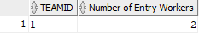

1. Description:

This query returns the total number of entry level researchers for each research team. A joined table from employees, research_team_researchers, rserache_teams will be formed. The results are aggregated and ordered on “teamid”.

1. Count the number of entry level employees in business teams.
   1. SQL code:

SELECT BUSINESS_TEAMS.business_teamid, count(*) AS "Number of Entry Workers"

FROM EMPLOYEES

    JOIN BUSINESS_TEAM_SALE_REP ON BUSINESS_TEAM_SALE_REP.empid = EMPLOYEES.empid

    JOIN BUSINESS_TEAMS ON BUSINESS_TEAMS.business_teamid = BUSINESS_TEAM_SALE_REP.teamid

WHERE EMPLOYEES.title = 'Entry'

GROUP BY BUSINESS_TEAMS.business_teamid

ORDER BY BUSINESS_TEAMS.business_teamid

;

1. Results:

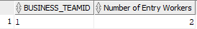

1. Description:

This query returns the total number of entry level workers for each business team. A joined table from employees, business_team_sale_rep, business_teams will be formed. The results are aggregated and ordered on “teamid”.

1. Count employee's publication number after 2019-12-31.
   1. SQL code:

SELECT EMPLOYEES.empid, count(*) AS "New Publications"

FROM EMPLOYEES

    JOIN EMPLOYEESWRITEPUB ON EMPLOYEESWRITEPUB.empid = EMPLOYEES.empid

    JOIN PUBLICATIONS ON PUBLICATIONS.publicationid = EMPLOYEESWRITEPUB.publicationid

WHERE PUBLICATIONS.publicationdate >= TO_DATE('2019-12-31', 'YYYY-MM-DD')

GROUP BY EMPLOYEES.empid

ORDER BY EMPLOYEES.empid

;

1. Results:

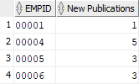

1. Description:

This query returns the number of publications for each employee that has publications. A joined table from employees, employeeswritepub, publications will be formed. The results are aggregated and ordered on the “empid”.

1. Show departments that have imposed regulation in the US.
   1. SQL code:

SELECT *

FROM DEPARTMENTS

WHERE DEPARTMENTS.deptid IN (SELECT DEPARTMENTS.deptid FROM DEPARTMENTS

    JOIN DEPARTREGULATION ON DEPARTREGULATION.deptid = DEPARTMENTS.deptid

    JOIN REGULATIONS ON REGULATIONS.regulationid = DEPARTREGULATION.regulationid

    WHERE REGULATIONS.country = 'US')

ORDER BY DEPARTMENTS.deptid

;

1. Results:

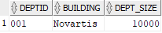

1. Description:

This query returns any departments that have something to do with regulations in the US. The query joins the departments table and regulation table, and selects the department that has a regulation country equals ‘US’.

1. Select orders that have payment exceeding 2000.
   1. SQL code:

SELECT *

FROM ORDERS

WHERE ORDERS.orderid IN (SELECT ORDER_DETAILS.orderid

    FROM ORDER_DETAILS

    HAVING SUM(ORDER_DETAILS.unitprice * ORDER_DETAILS.quantity) > 2000

    GROUP BY ORDER_DETAILS.orderid)

;

1. Results:

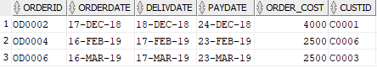

1. Description:

This query first constructs a sub query for finding order IDs that have payment more than 2000. Then, it sub-selects orders’ information by mapping into the sub query.

1. Select orders that diliverdate - orderdate < 2.
   1. SQL code:

SELECT *

FROM ORDERS

WHERE ORDERS.delivdate - ORDERS.orderdate < 2

;

1. Results:

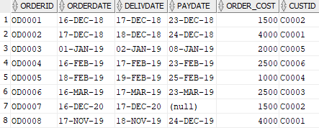

1. Description:

This query returns all the orders that have been delivered in one day.

1. Calculate sale in different states.
   1. SQL code:

SELECT CUSTOMERS.cust_location, SUM(ORDER_DETAILS.unitprice * ORDER_DETAILS.quantity) AS "Sale Total"

FROM ORDERS

    JOIN ORDER_DETAILS ON ORDER_DETAILS.orderid = ORDERS.orderid

    JOIN CUSTOMERS ON CUSTOMERS.custid = ORDERS.custid

GROUP BY CUSTOMERS.cust_location

ORDER BY CUSTOMERS.cust_location

;

1. Results:

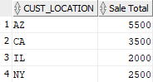

1. Description:

This query returns the total sale in different states. The sale is calculated by the unit price times the quantity sold in each order. Then, the total sale is aggregated on the sale by the order ID.

1. Quantity sold, at inventory, produced for each kind of covid product.
   1. SQL code:

WITH PRODUCT_SOLD AS

(

SELECT ORDER_DETAILS.prodid, SUM(ORDER_DETAILS.quantity) AS "Sold"

FROM ORDER_DETAILS

GROUP BY ORDER_DETAILS.prodid

), PRODUCT_PRODUCED AS

(

SELECT PRODUCT_PRODUCE_LOGS.prodid, SUM(PRODUCT_PRODUCE_LOGS.quantityproduced) AS "Produced"

FROM PRODUCT_PRODUCE_LOGS

GROUP BY PRODUCT_PRODUCE_LOGS.prodid

)

SELECT PRODUCTS.prodid, PRODUCTS.prodname, PRODUCTS.inventory, PRODUCT_SOLD."Sold" As "Sold", PRODUCT_PRODUCED."Produced" AS "Produced"

FROM PRODUCTS

    JOIN PRODUCT_SOLD ON PRODUCTS.prodid = PRODUCT_SOLD.prodid

    JOIN PRODUCT_PRODUCED ON PRODUCTS.prodid = PRODUCT_PRODUCED.prodid

WHERE PRODUCTS.prodname IN ('Covid19 vaccine 1st', 'Covid19 vaccine 2st', 'Covid19 vaccine 3st')

ORDER BY PRODUCTS.prodid

;

1. Results:

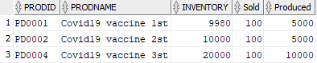

1. Description:

This query first constructs temporary panels recording the quantity of sold products and produced products for covid19. Then, it gathers the inventory information together with the former two to the results.

1. Select the patientid, patient first name, patient last name who has the Covid-19.
   1. SQL code:

SELECT pat.patientid, pat.patientfn, pat.patientln

FROM projects pro

JOIN research_projects rp ON pro.projectid = rp.projectid

JOIN patients pat ON pat.researchprojectid = rp.projectid

WHERE pro.title = 'Covid-19'

ORDER BY pat.patientid

;

1. Results:

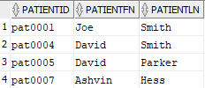

1. Description:

This query finds the patient participating in the projects that has something to do with covid19. The information of the patients will be exemplified as well.

1. Select the Moderma Projects which are in phase 2.
   1. SQL code:

SELECT pro.title, pro.startdate

FROM projects pro

JOIN research_projects rp ON pro.projectid = rp.projectid

where rp.phase = 2

;

1. Results:

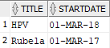

1. Description:

This query finds the projects that are in phase two. A joined table from projects, research_projects will be formed.

1. Select the employees who have expert-level communication skills.
   1. SQL code:

SELECT emp.empid, emp.EMPFN, emp.EMPLN

FROM employees emp

JOIN skill_details sd ON emp.empid = sd.empid

JOIN skills sk ON sk.skillid = sd.skillid

WHERE sk.SKILLDESCRIPTION='communication skill' and sd.SKILLLEVEL = 'expert'

;

1. Results:

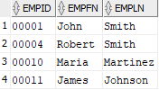

1. Description:

This query finds the employees that have expert-level communication skills. A joined table from employees, skill, skill_detail will be formed and searched.

1. Display only the employees who have publications.
   1. SQL code:

SELECT emp.empid, emp.empfn, emp.empln, count(*) as "PubNum"

FROM employees emp

JOIN employeeswritepub ew ON emp.empid = ew.empid

GROUP BY emp.empid, emp.empfn, emp.empln

ORDER BY emp.empid

;

1. Results:

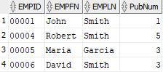

1. Description:

This query finds the employees that have any publications. A joined table from employees and employeeswritepub will be formed.

Chapter 5: Triggers and Procedures

In this chapter, we will introduce 3 triggers and 1 procedure that are aimed to solve the problems that probably happen in the real business environment when data records are updated, inserted, and deleted.  Because some of the tables are closely related to each other, the adjustments of one table could result in the data inconsistency of multiple tables. The triggers and the procedures are designed to prevent this situation.

Triggers:

1. Updating the table ORDERS if table ORDER_DETAILS is changed.
2. SQL Code:

CREATE OR REPLACE TRIGGER order_update

    before insert or delete or update on order_details

for each row

declare

oldOrderCost ORDERS.order_cost%type ;

begin

    IF(:new.orderid is null) then

    select orders.order_cost into oldOrderCost from orders

    where orders.orderid = :old.orderid;

    update orders set order_cost = oldOrderCost - :old.quantity * :old.unitprice

        where orders.orderid = :old.orderid;

    elsif(:old.orderid is null) then

        select orders.order_cost into oldOrderCost from orders

        where orders.orderid = :new.orderid;

        update orders set order_cost = oldOrderCost + :new.quantity * :new.unitprice

            where orders.orderid = :new.orderid;

    else

        select orders.order_cost into oldOrderCost from orders

        where orders.orderid = :new.orderid;

        update orders set order_cost = oldOrderCost + :new.quantity * :new.unitprice - :old.quantity * :old.unitprice

            where orders.orderid = :new.orderid;

    END IF;

end;

/

1. Results:

Before update:

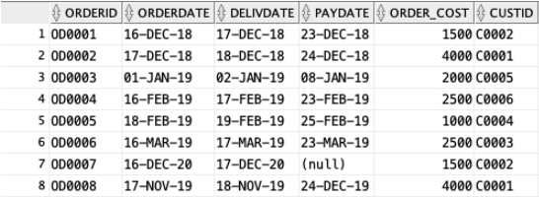

After updating the order OD0005:

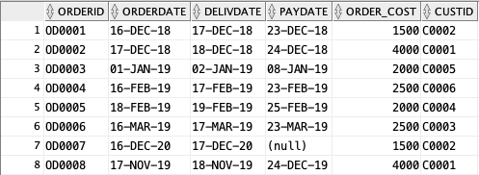

1. Description:

In a real business scenario, orders are often modified or returned. In this case, the ORDERS and ORDER_DETAILS tables are affected by the changing of the order records. The ORDER_DETAILS is updated first because it lists all the products that are included in every order, and we want to automatically update the corresponding records in the table ORDERS.

1. Updating the table PRODUCTS if table PRODUCT_PRODUCE_LOG is changed.
2. SQL Code:

before insert or delete or update on PRODUCT_PRODUCE_LOGS

for each row

declare

oldInventory PRODUCTS.inventory%type ;

begin

    IF(:new.prodID is null) then

    select PRODUCTS.inventory into oldInventory from PRODUCTS

    where PRODUCTS.prodID = :old.prodID;

    update PRODUCTS set inventory = oldInventory - :old.quantityProduced

        where PRODUCTS.prodID = :old.prodID;

    elsif(:old.prodID is null) then

        select PRODUCTS.inventory into oldInventory from PRODUCTS

        where PRODUCTS.prodID = :new.prodID;

        update PRODUCTS set inventory = oldInventory + :new.quantityProduced

            where PRODUCTS.prodID = :new.prodID;

    else

        select PRODUCTS.inventory into oldInventory from PRODUCTS

        where PRODUCTS.prodID = :new.prodID;

        update PRODUCTS set inventory = oldInventory + :new.quantityProduced - :old.quantityProduced

            where PRODUCTS.prodID = :new.prodID;

    END IF;

end;

/

1. Results:

Before update:

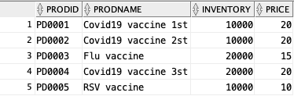

After updating the order PD0001:

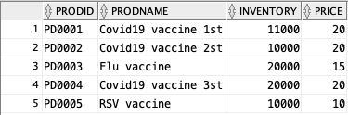

1. Description:

In a real business scenario, there might be errors during shipping from the manufacturers. Thus, sometimes inventories should be adjusted to ensure data consistency. In this case, the PRODUCTS and PRODUCT_PRODUCE_LOGS tables are affected by the changing of the inventory numbers. The RODUCT_PRODUCE_LOGS table is updated first because it lists all the products that are produced by every manufacturer, and we want to automatically update the corresponding records in the table PRODUCTS.

1. Output the employee summary.
2. SQL Code:

CREATE OR REPLACE TRIGGER employees_summary

    after insert or delete or update on employees

declare

entrynum number(2);

renum number(2);

srnum number(2);

begin

    select count(*) into entrynum

    from employees

    where employees.title = 'Entry';

    dbms_output.put_line('Number of Entry Level: '||entrynum);

    select count(*) into renum

    from employees

    where employees.worktype = 'RE';

    dbms_output.put_line('Number of Researchers: '||renum);

    select count(*) into srnum

    from employees

    where employees.worktype = 'SR';

    dbms_output.put_line('Number of Sales Re-pre: '||srnum);

end;

/

1. Results:

Output:

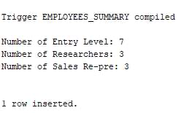

1. Description:

After adding a new employee or updating an existing record for an employee to the table, we want to know some details of the entire EMPLOYEES table. This trigger will output some summarized information about the employee.

Procedures:

1. Log the overdue orders.
2. SQL Code:

CREATE SEQUENCE ool_id_seq

    START WITH 1000

    MAXVALUE 9999

    ;

CREATE OR REPLACE procedure archive_overdue_orders AS

CURSOR cursor1 IS

    SELECT orderid, orderDate, paydate, CustID

    FROM orders

    WHERE (paydate is null and (sysdate - orderdate) > 15) or (paydate - orderdate) > 15;

sdate date;

BEGIN

    for entry in cursor1 loop

        if entry.paydate is null then

            sdate := sysdate;

        else

            sdate := entry.paydate;

        end if;

        insert into overdue_orders_log values('ol'||ool_id_seq.nextval,entry.orderid, entry.orderdate,

            entry.paydate, entry.custid, round(sdate - entry.orderdate - 15), sysdate);

    end loop;

END;

/

1. Results:

Order ‘OD0007’ and ‘OD0008’ are overdue:

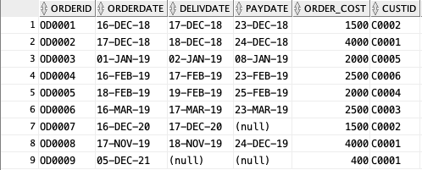

Record the overdue orders:

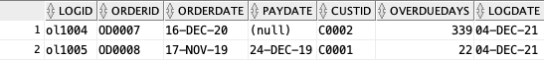

c. Description:

There are some overdue orders that might become “bad accounts.” We want to create a specific table to record all the overdue orders and calculate the number of days overdue and logging date for future reference. Orders are considered overdue if payment hasn’t been made within 15 days of the order date.

Chapter 6: User Interface

The front end is specifically designed for the admin who is a super user and a senior management employee of Moderna. The super user has several privileges. These are categorized into 3 parts: 1. Editing and deleting the data from the front end which reflects in the tables, 2. Viewing derived information from the database to draw meaningful insights, 3. Adding new rows to the existing Tables

1. Edit/Delete Privileges for the Admin user include the following:

* Employee data
* Customer Orders based on the customers’ request
* Updating the product inventory
* The publications made by the employees working in projects
* Updating phase and modality of research and business projects
* Updating patients information

1. Viewing (uneditable information) privileges for the Admin user include:

* Sales Data, state wise segregation in USD
* Employees who have published papers in the field of medicine
* Employees who are expert communicators
* Customer order details
* Premium customer orders(exceeding $2000)
* Priority Orders that were delivered within 2 days
* COVID Inventory
* Top researchers from superclass Employees starting from the year 2020
* Research Projects in phase-2 of the development
* About Us page (Moderna Inc.)

1. Adding new rows to the existing Tables

* Add new employees
* Add new publications
* Insert data for new patients

1. The admin portal home screen snip:

Header Section: Includes the navigation to Home page, About us info, Sales Data and Employee Data

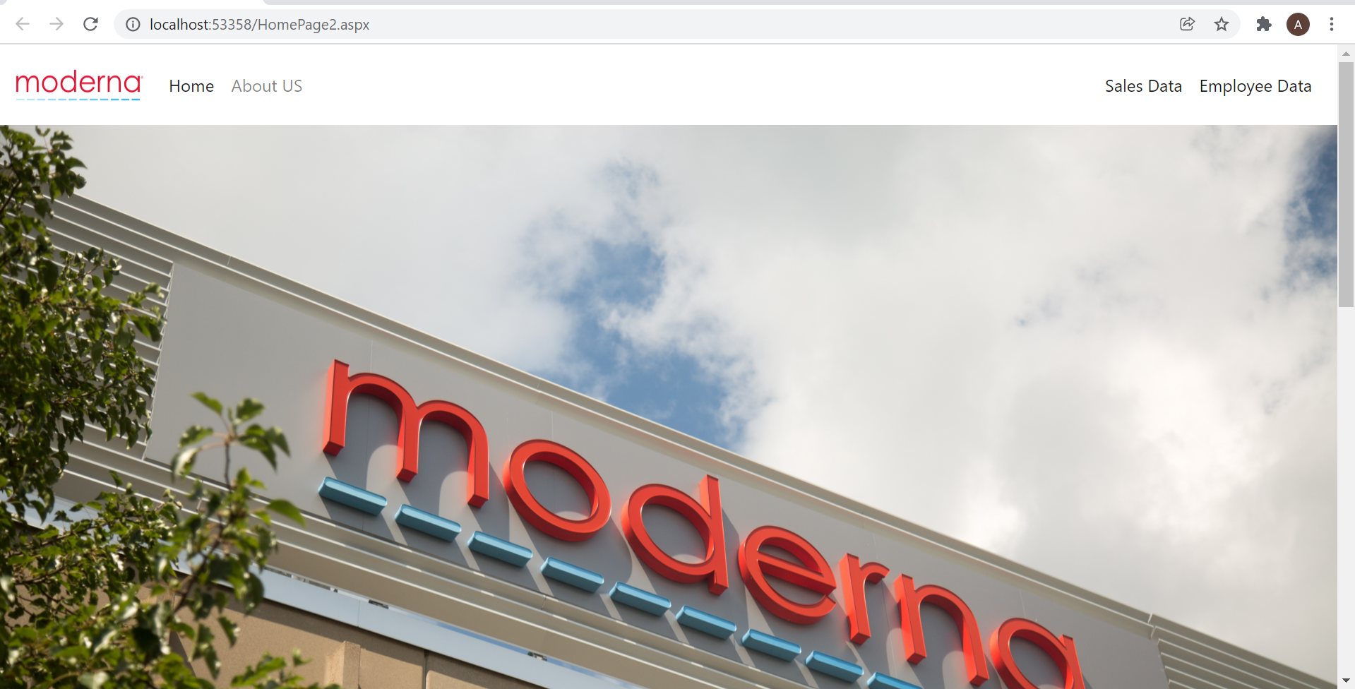

Footer Section: Includes the navigation to Customer Orders, Product Inventory, Publications, Projects and Patients

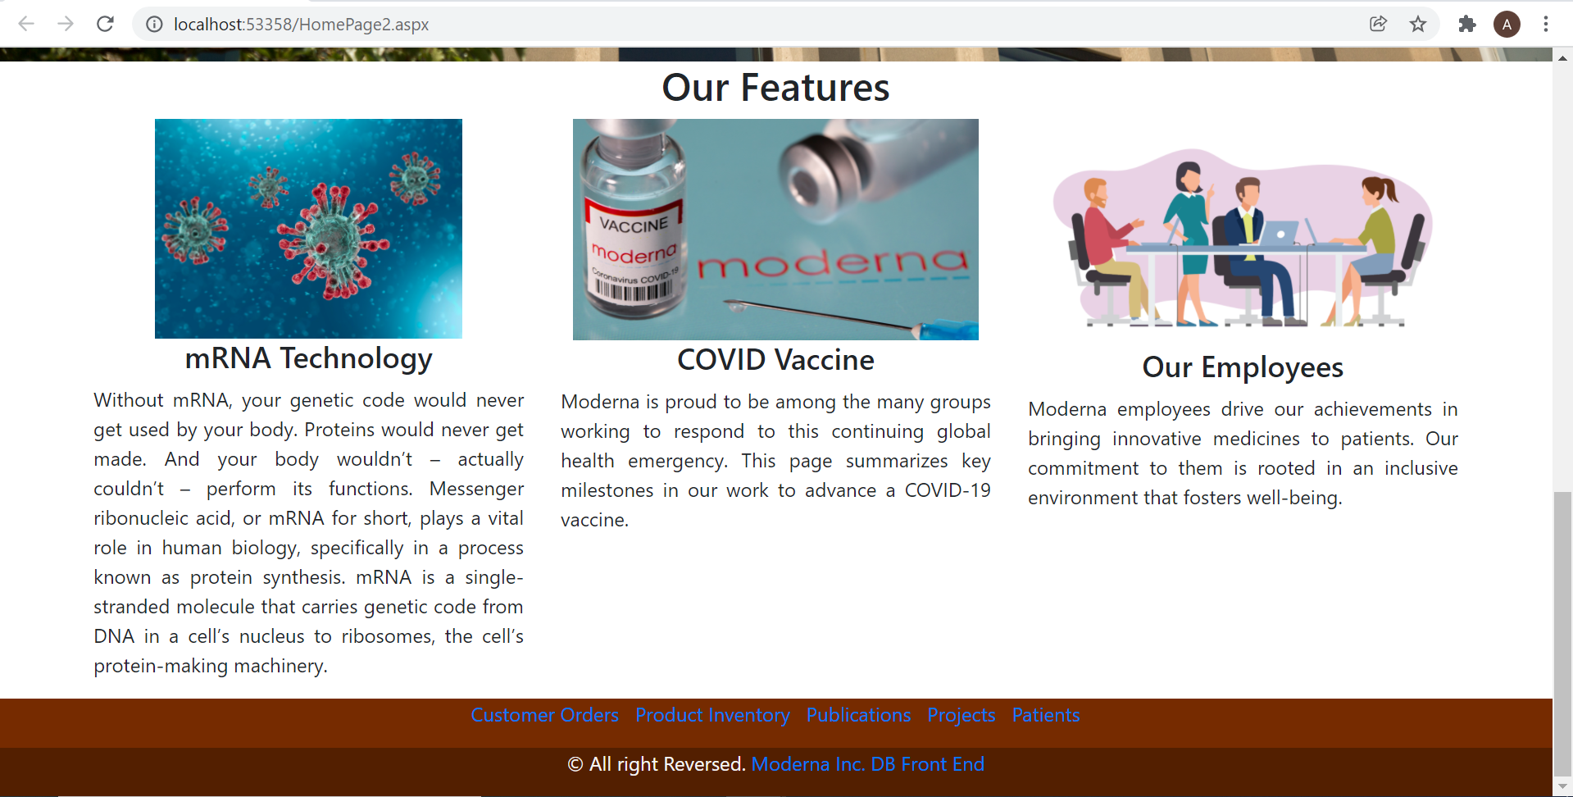

1. Editing and Deleting rows

* Employees Table

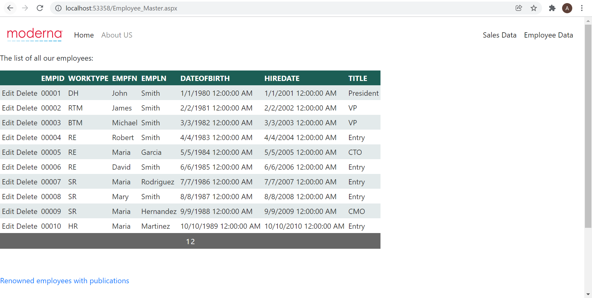

* Customers Orders Table

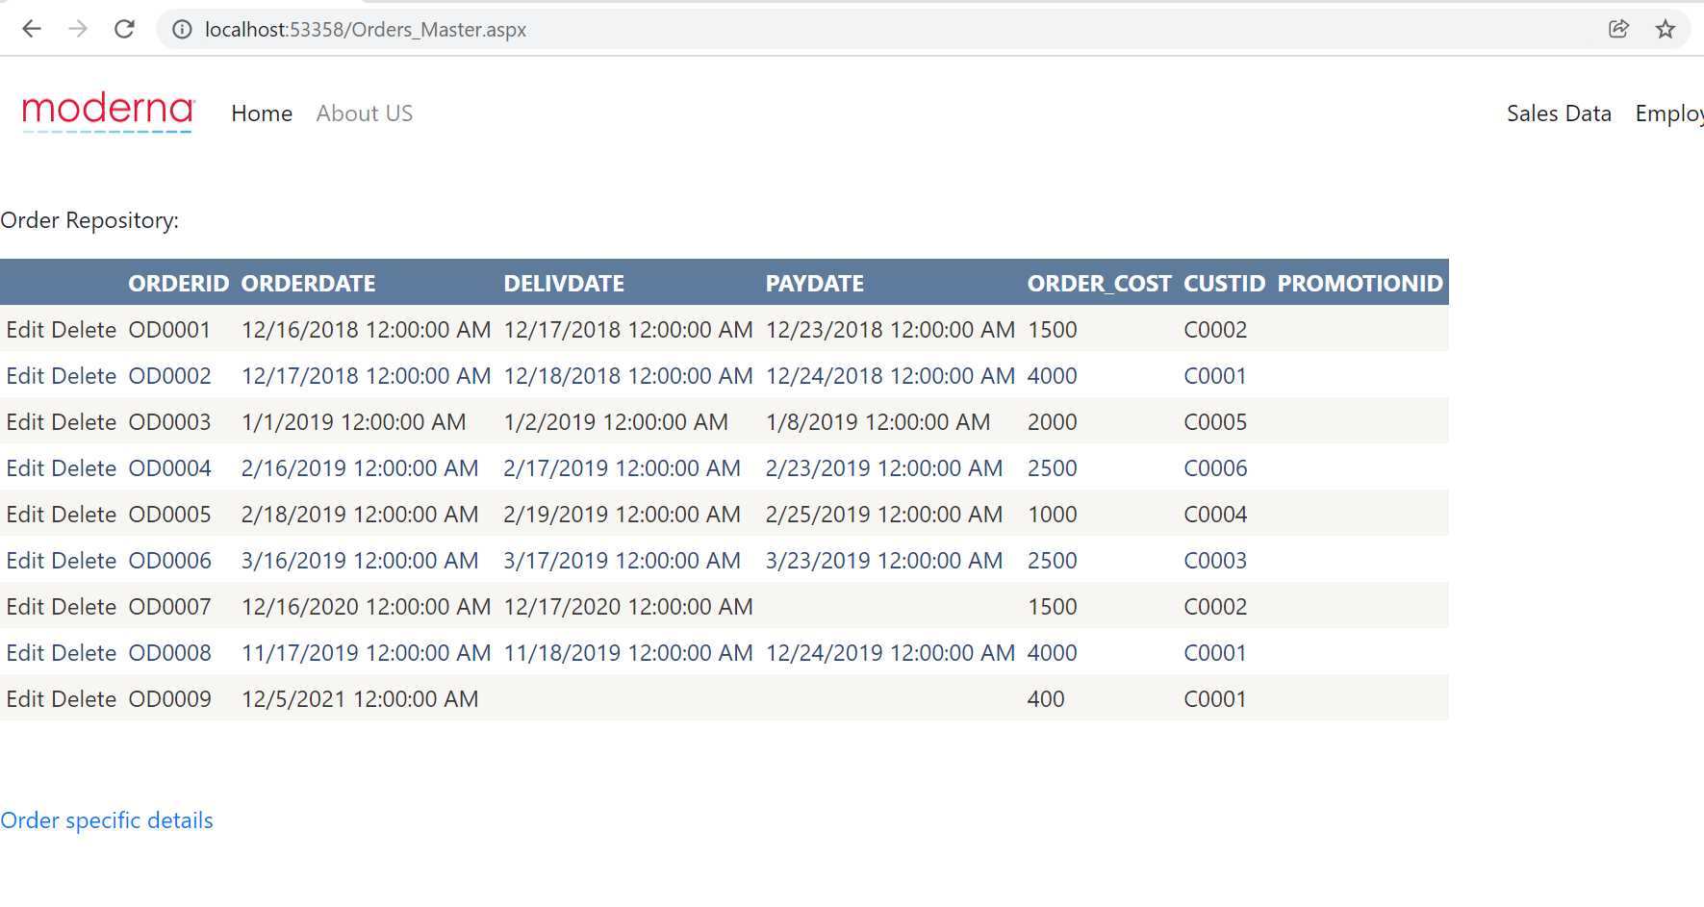

* Product Inventory

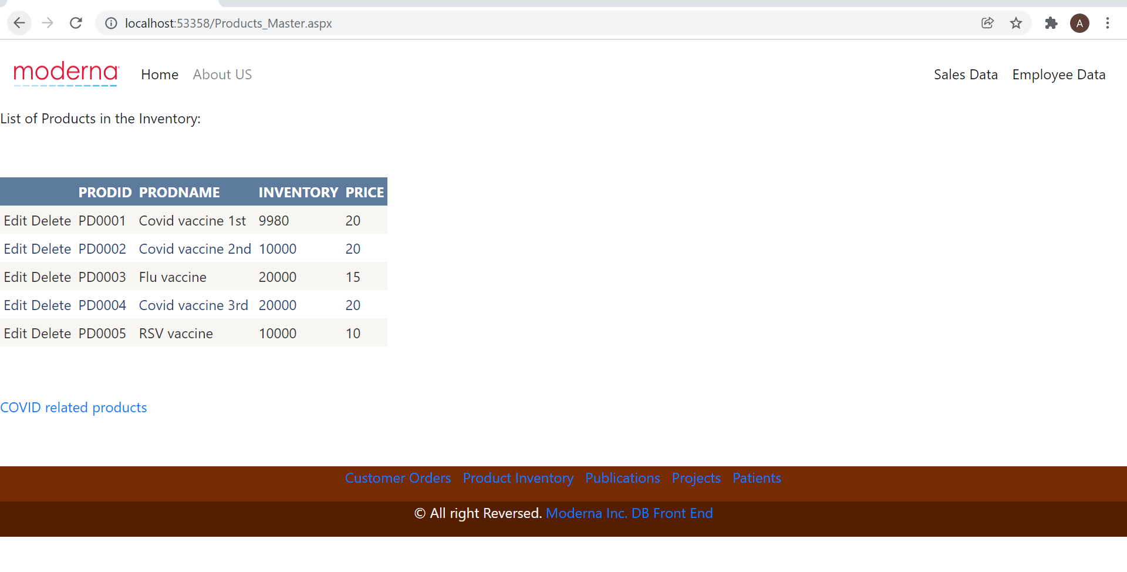

* List of all the publications

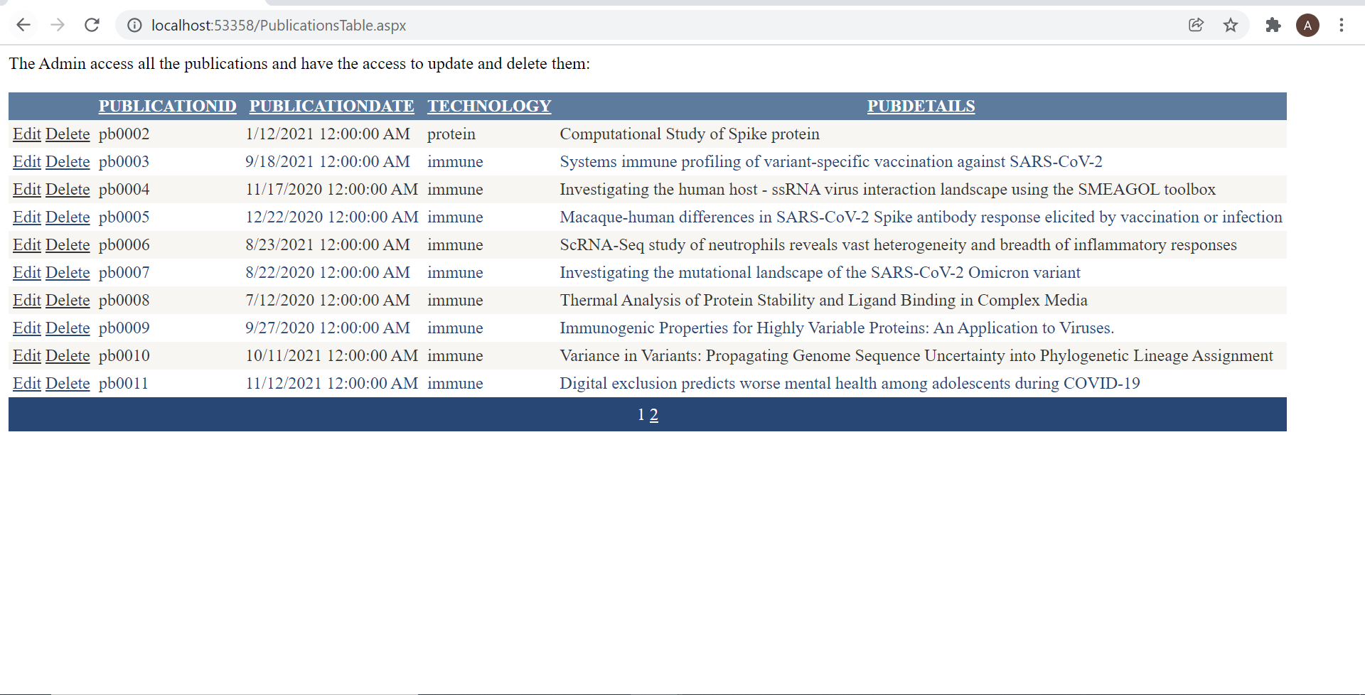

* Research Projects

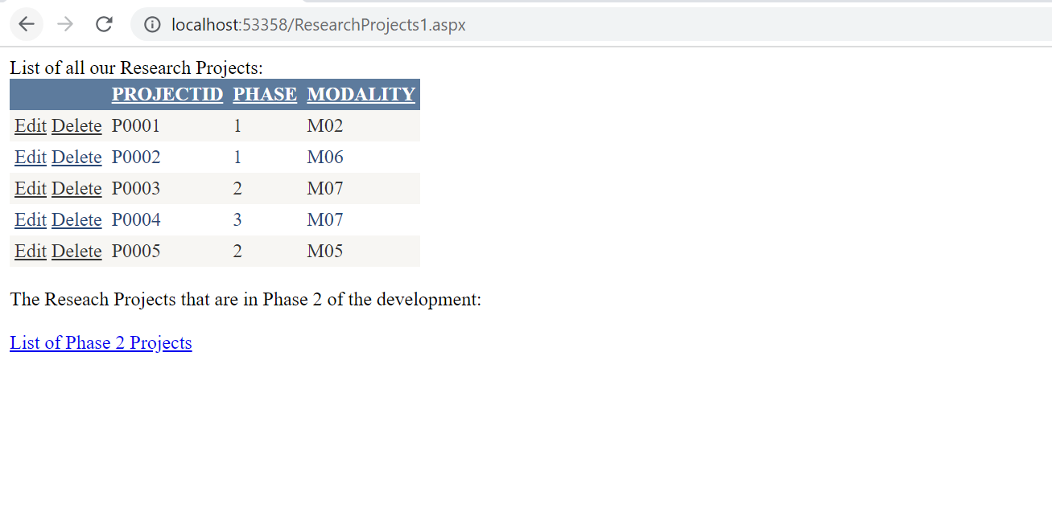

* Patient data (highly confidential)

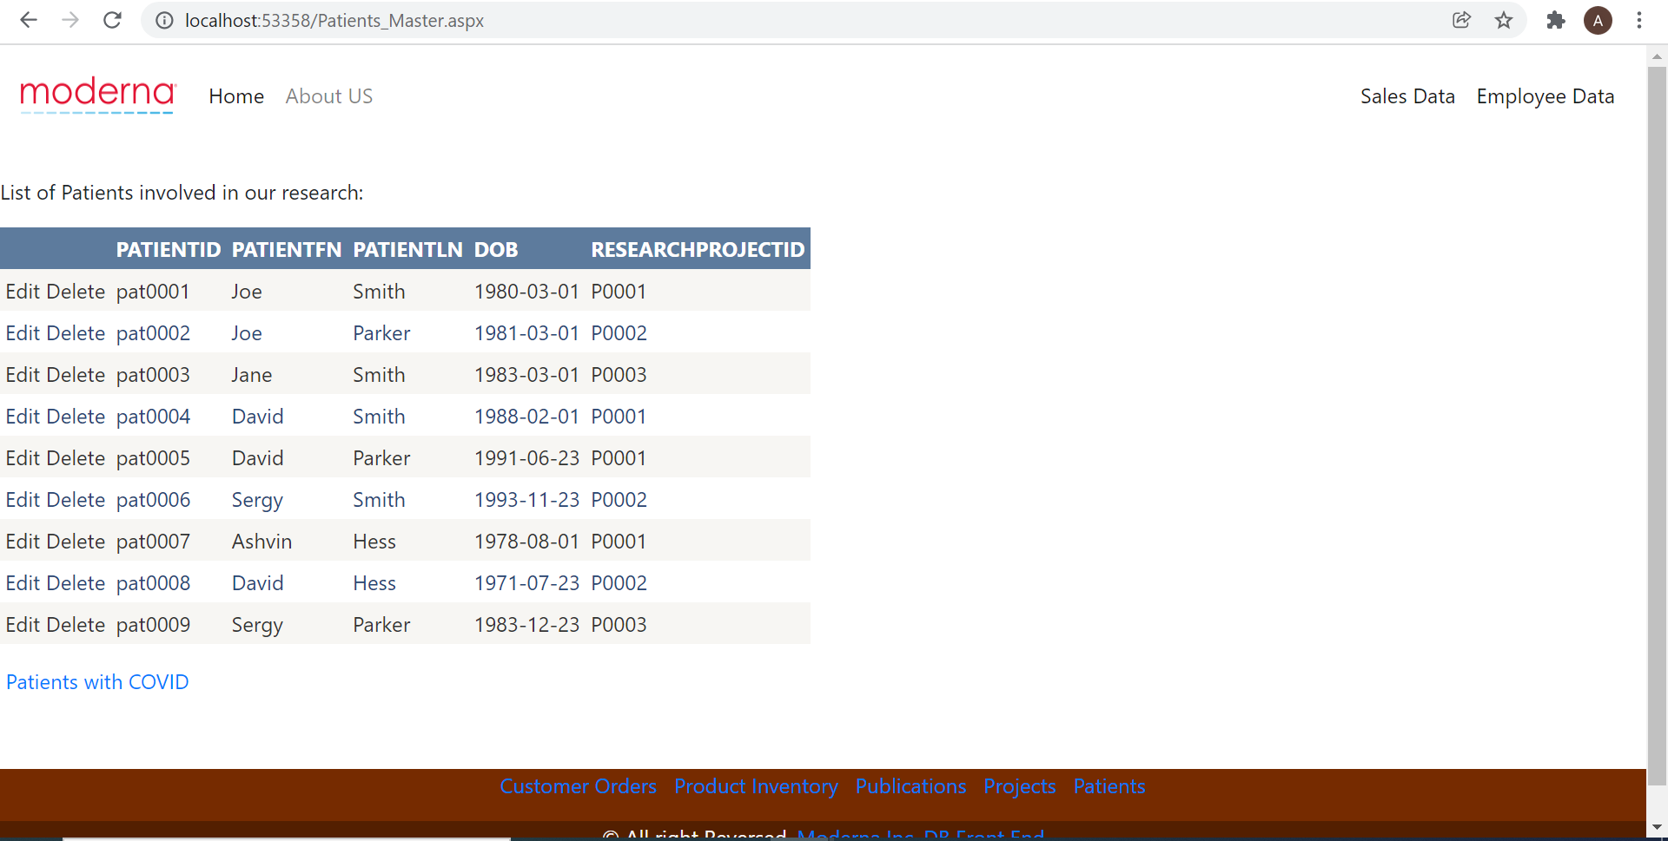

Furthermore, all the table with view access have been created on Views, flows are shown below:

Flow1: Home Screen -> Sales Data

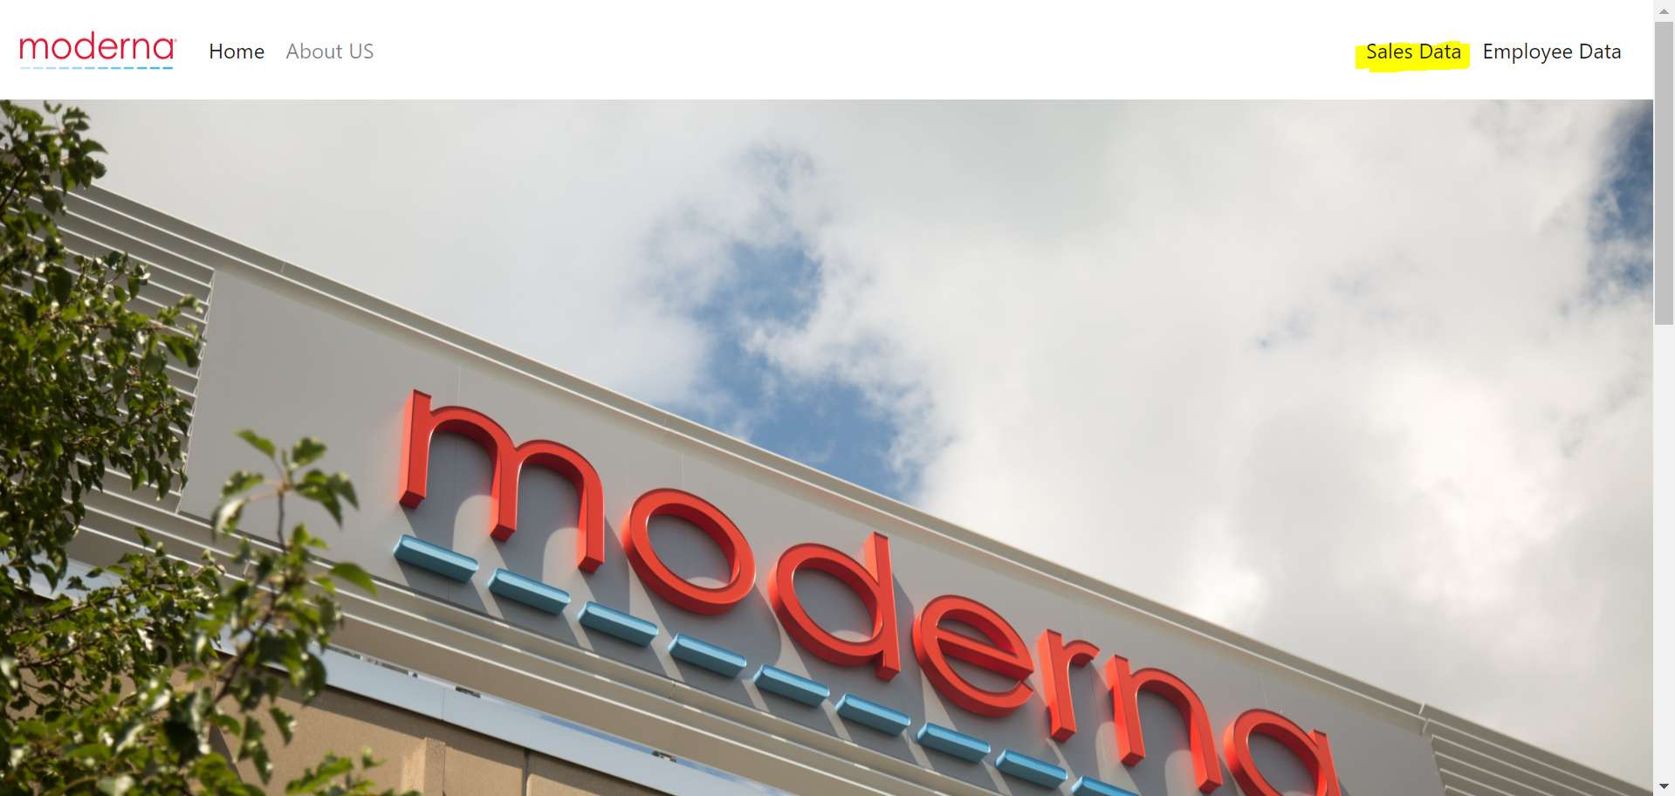

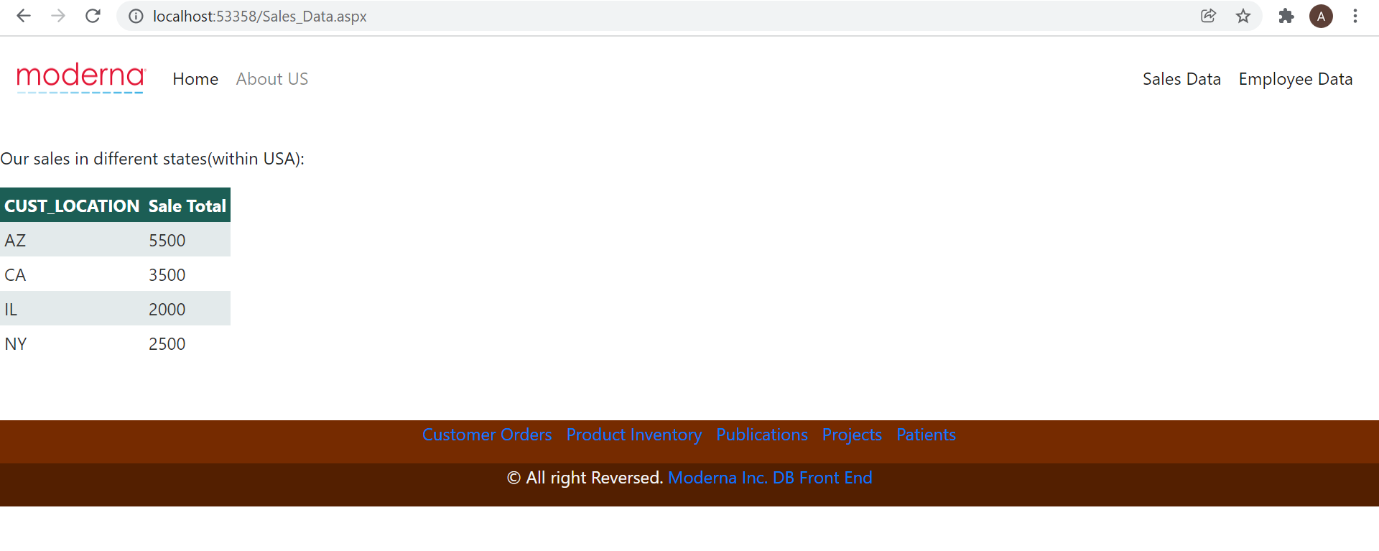

Flow 2: Home Screen -> Employee Data -> Renowned Employees(Paper Publishers)

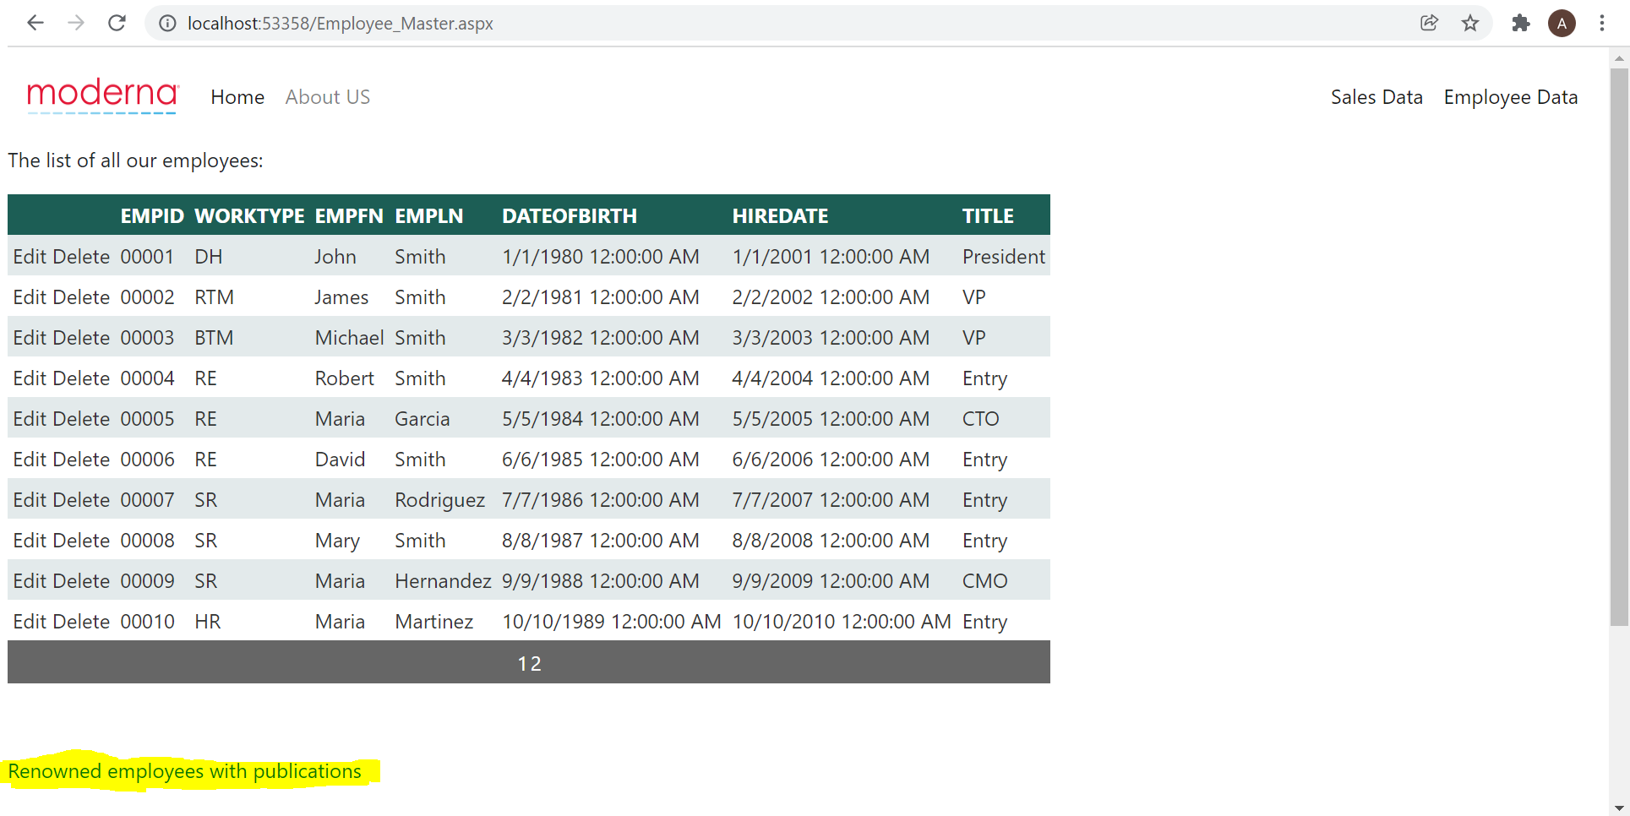

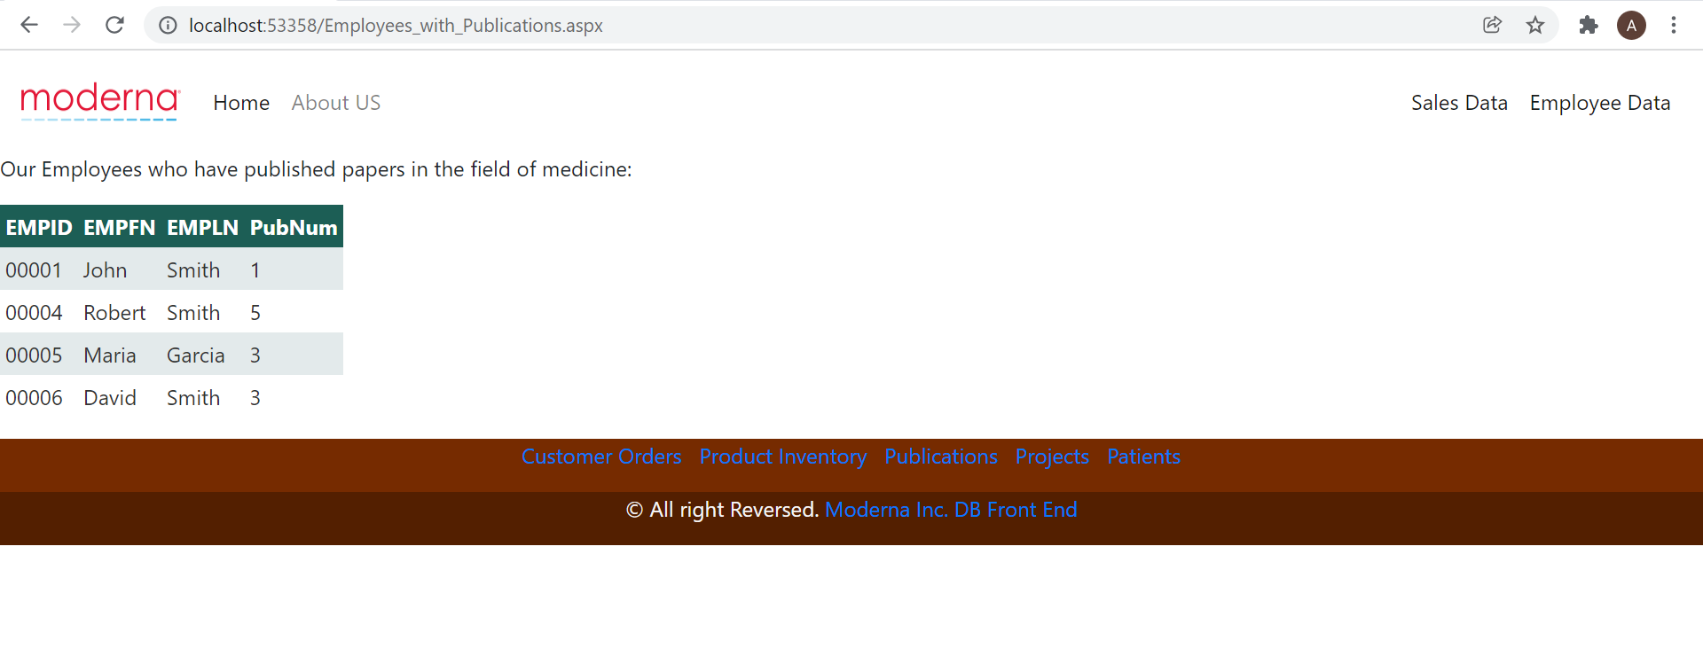

Flow 3: Home Page -> Employee Data -> Expert Communicators

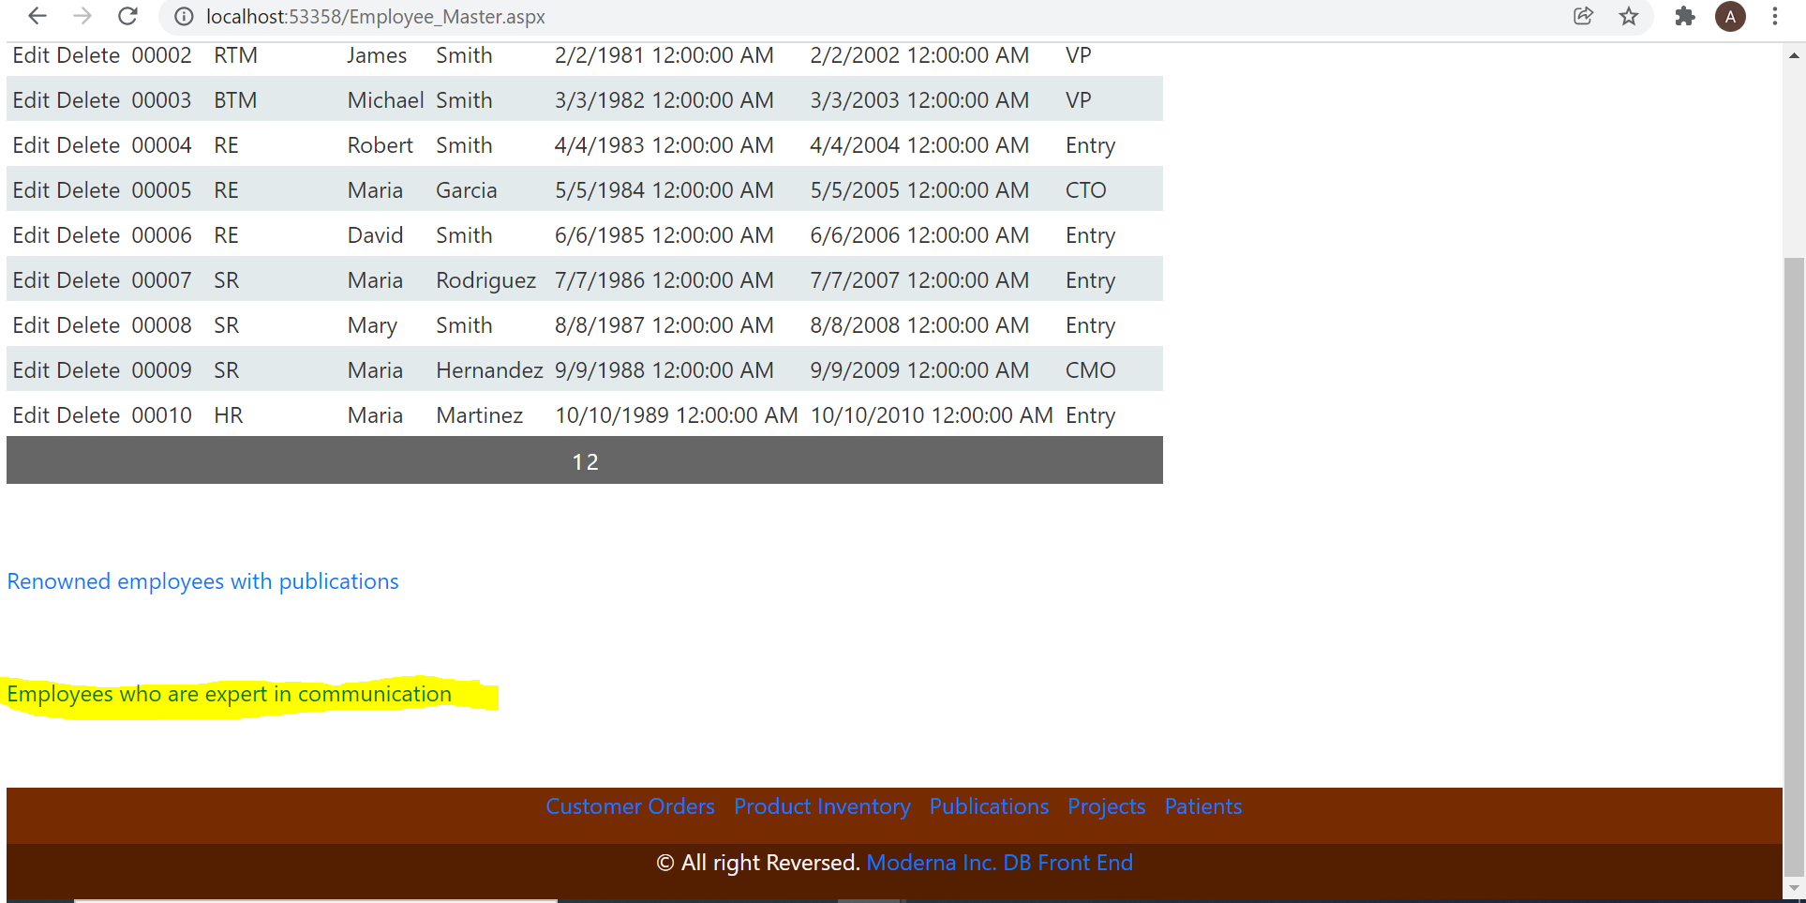

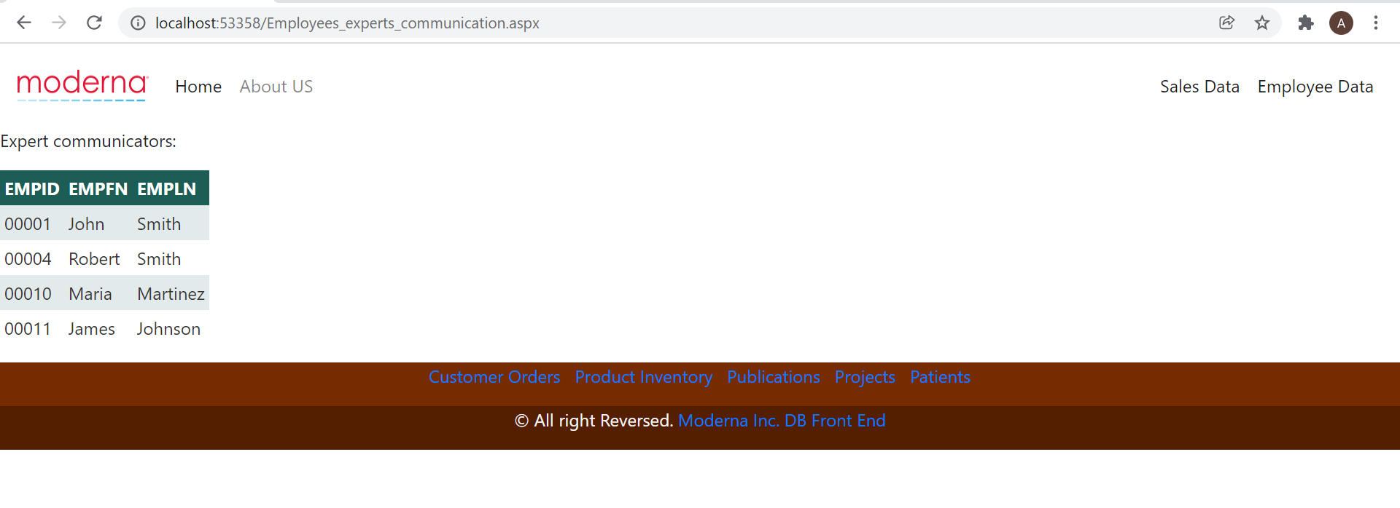

Flow 4: Home Page -> Customer Order -> Order Specific Details

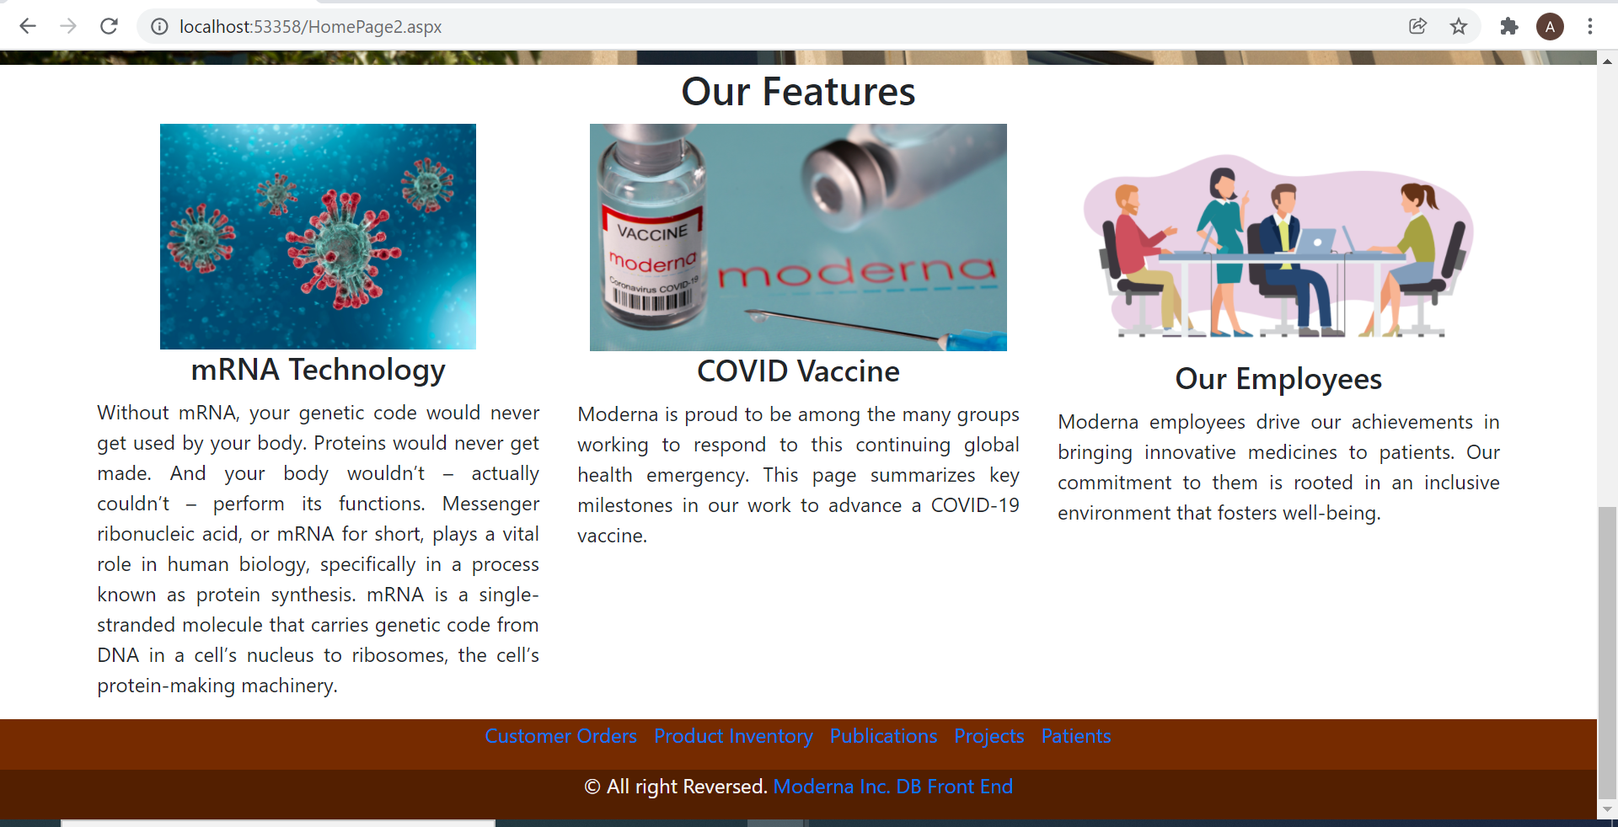

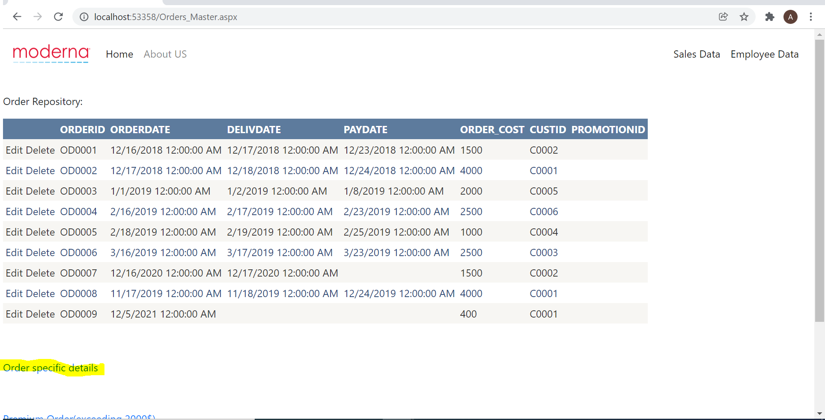

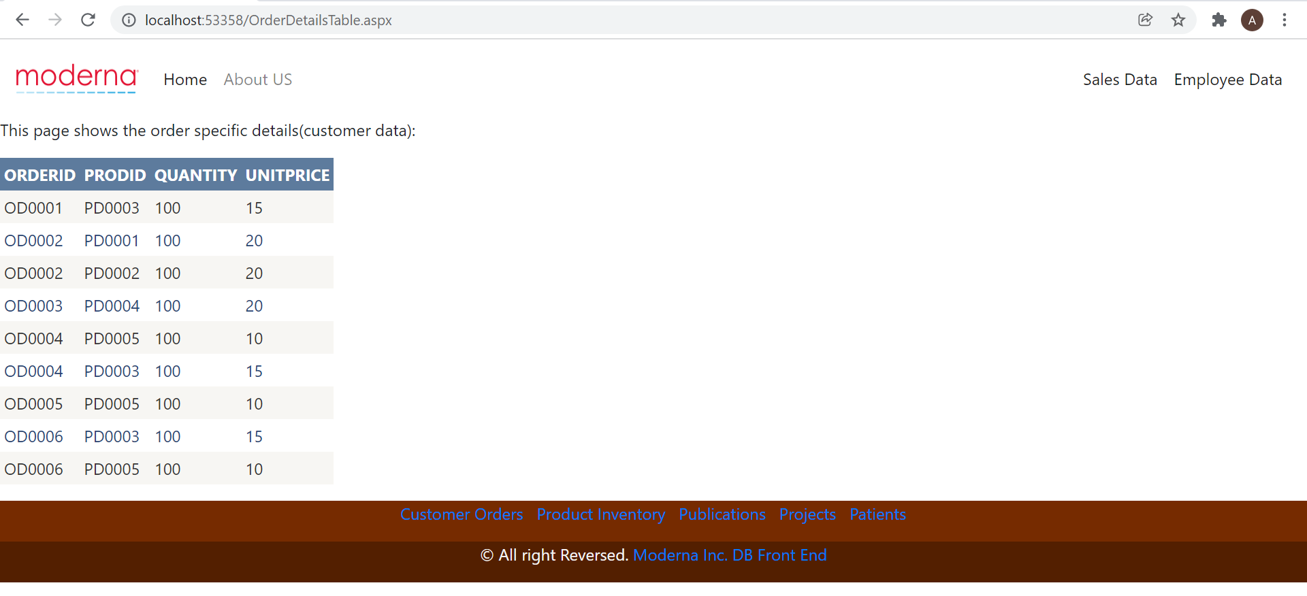

Flow 5: Home Page -> Customer Order -> Premium Orders

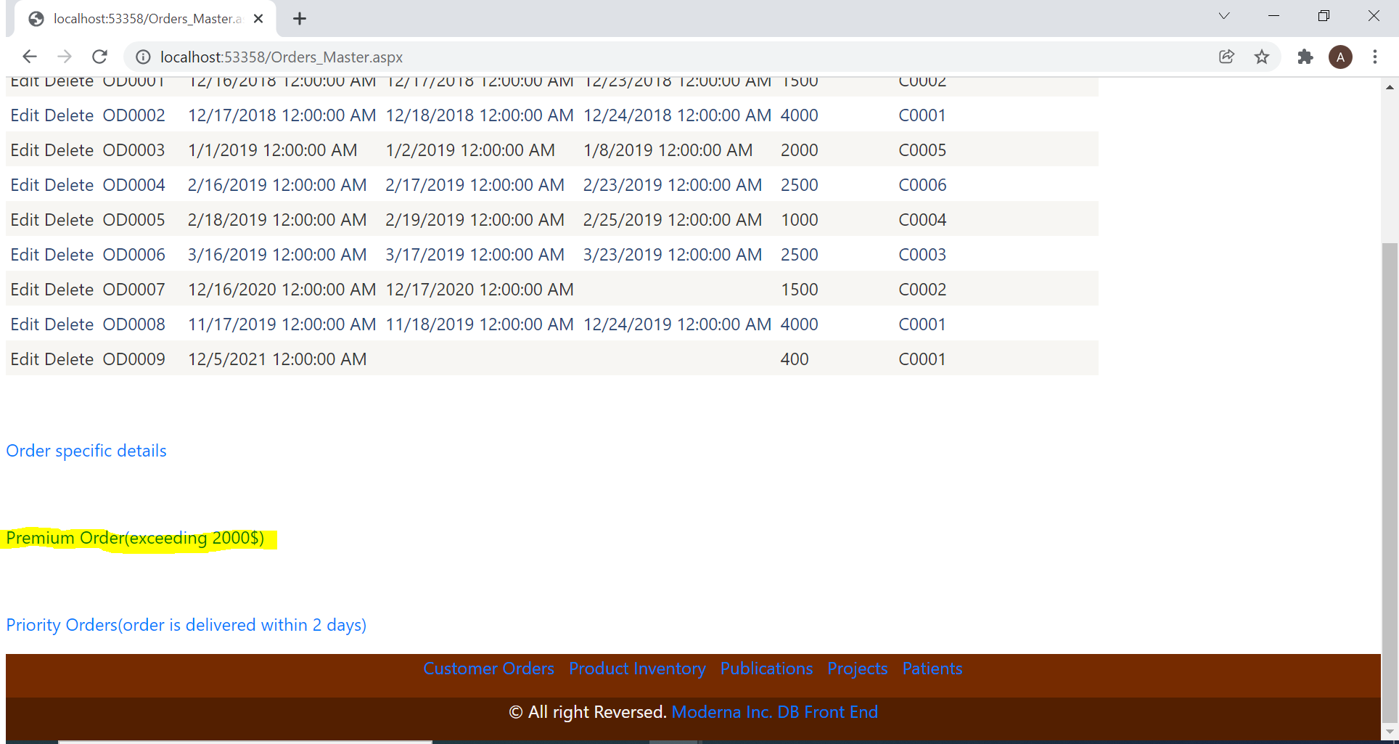

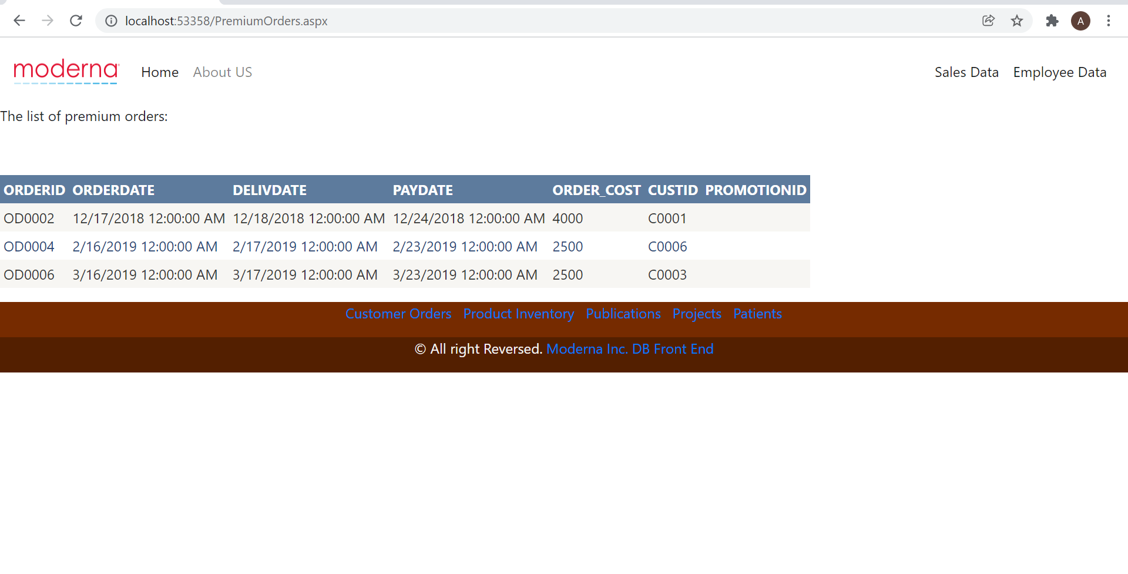

Flow 6: Home Page -> Customer Orders -> Priority Orders

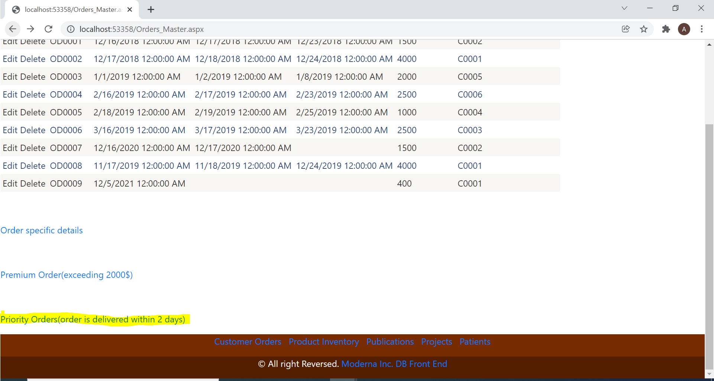

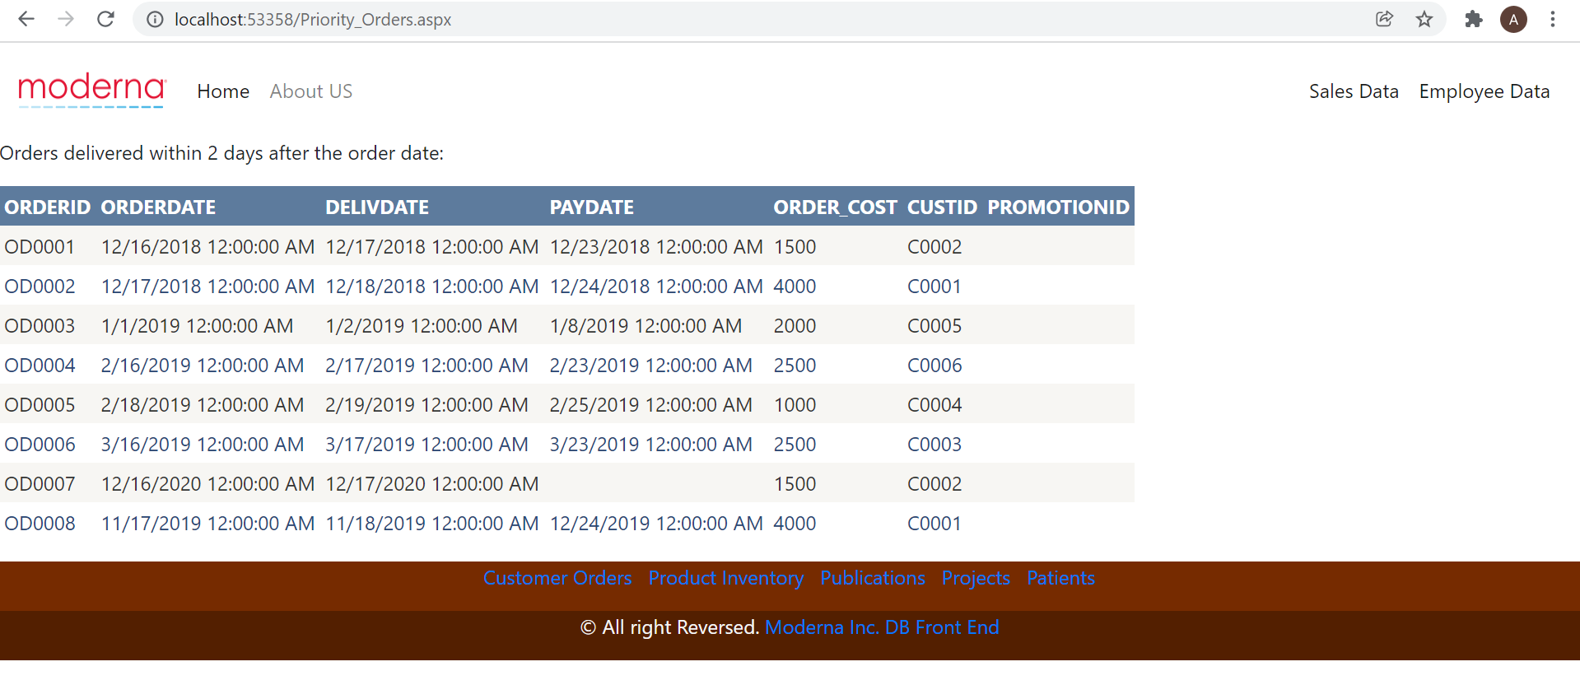

Flow 7: Home Page -> Product Inventory -> COVID related products

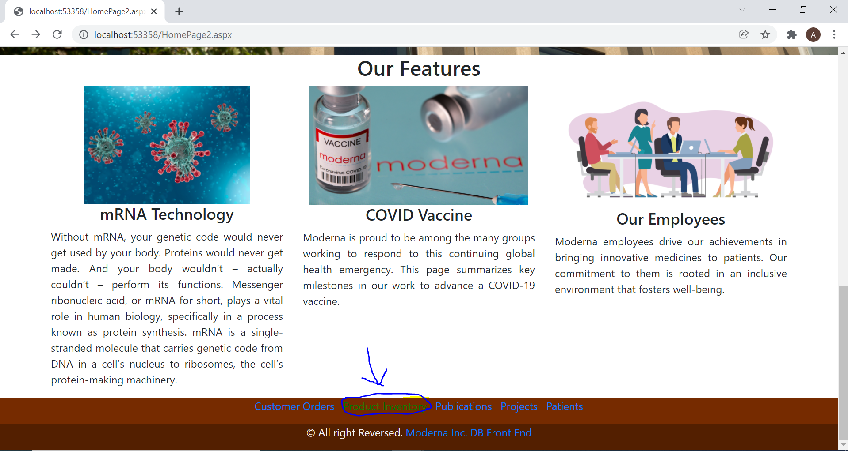

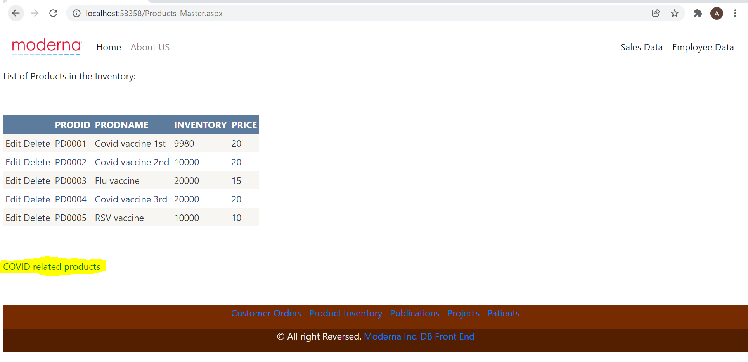

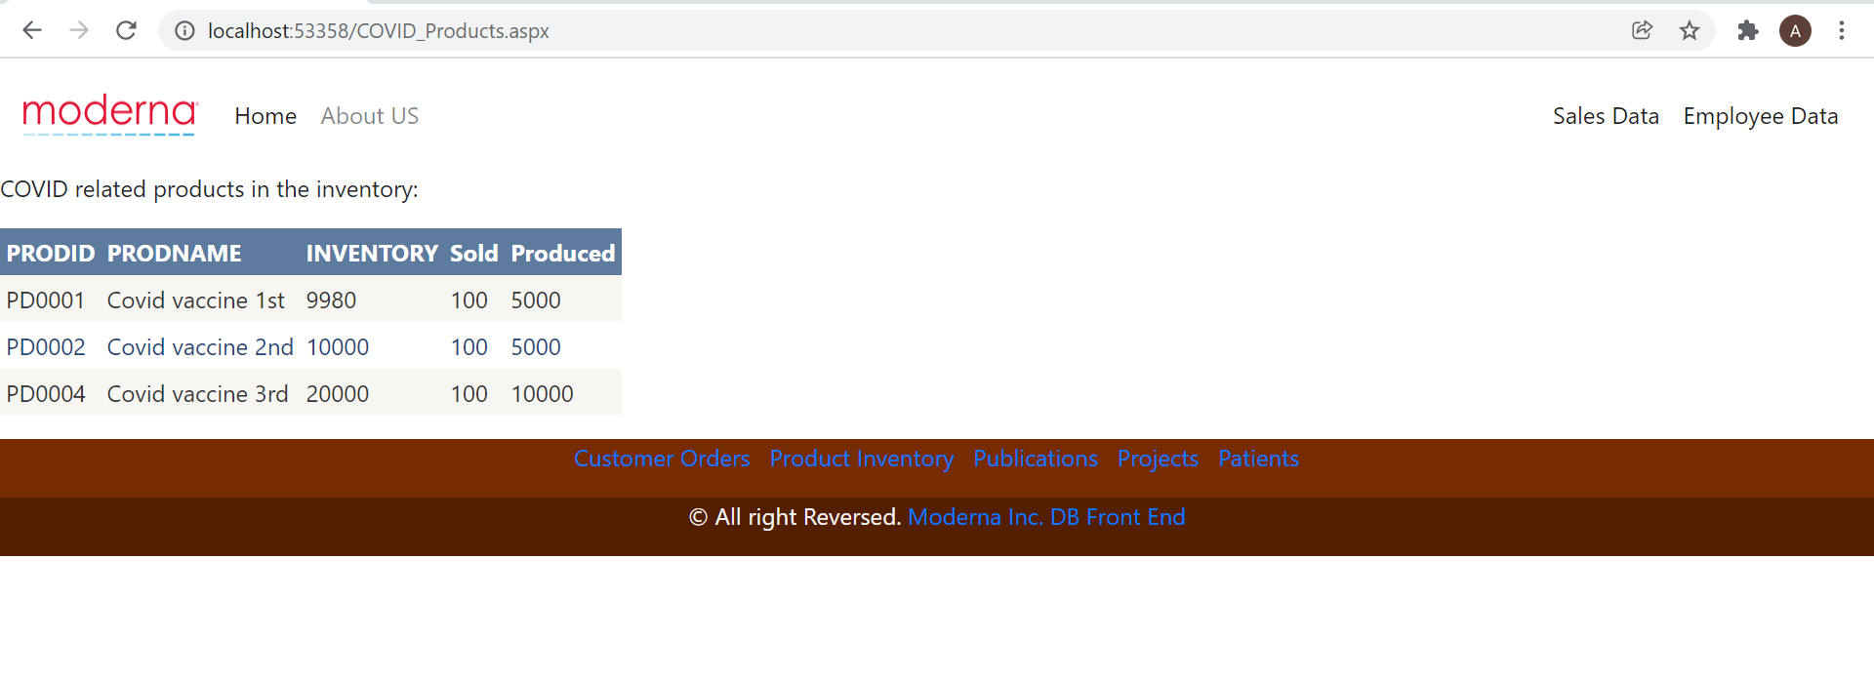

Flow 8: Home Page -> Publications -> Top Research Employees after 2019 starting from 2020

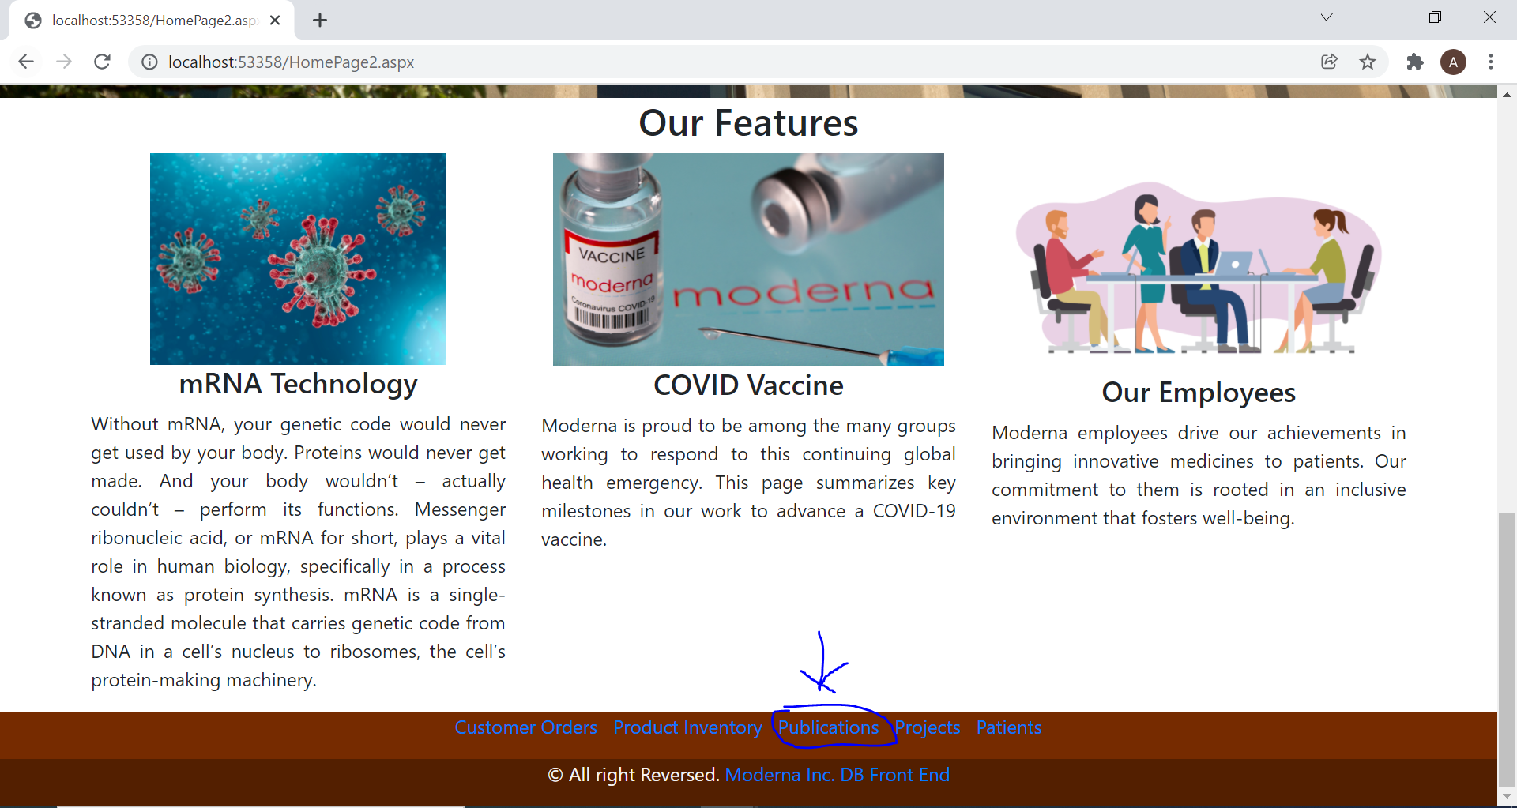

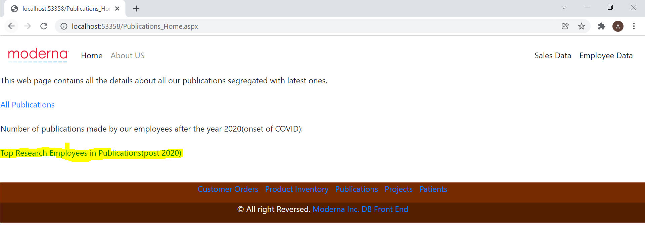

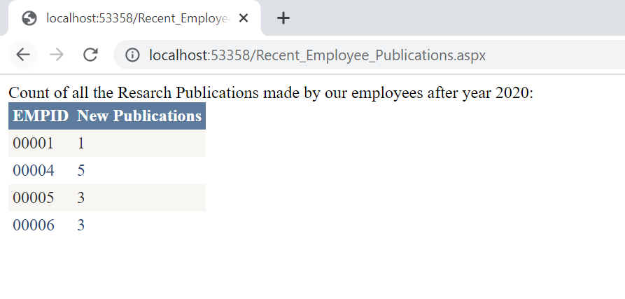

Flow 9: Home Page -> Projects -> Research Projects -> List of Phase 2 Projects

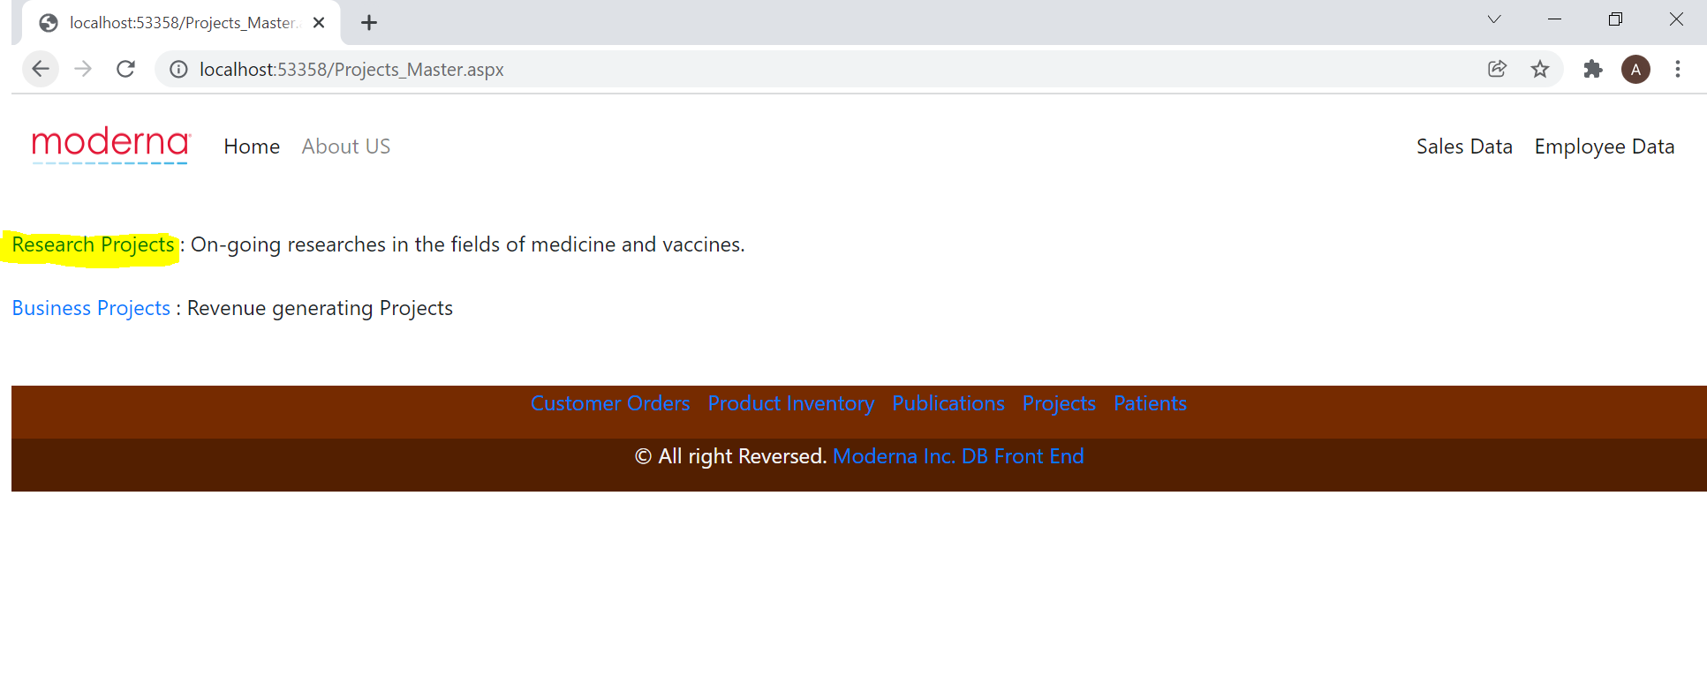

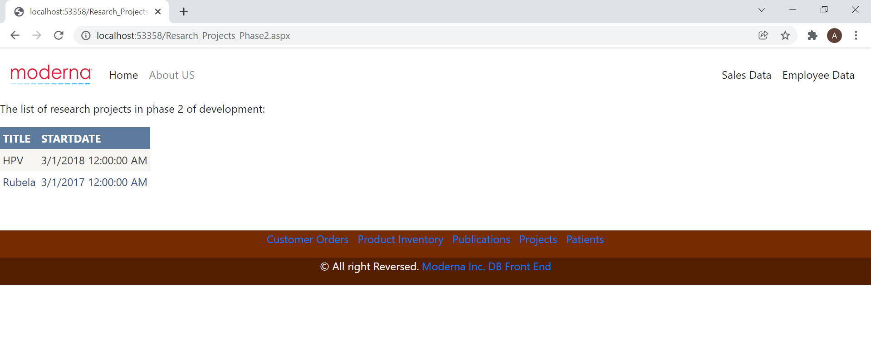

Flow 10: Home Page -> Patients -> Patients with COVID

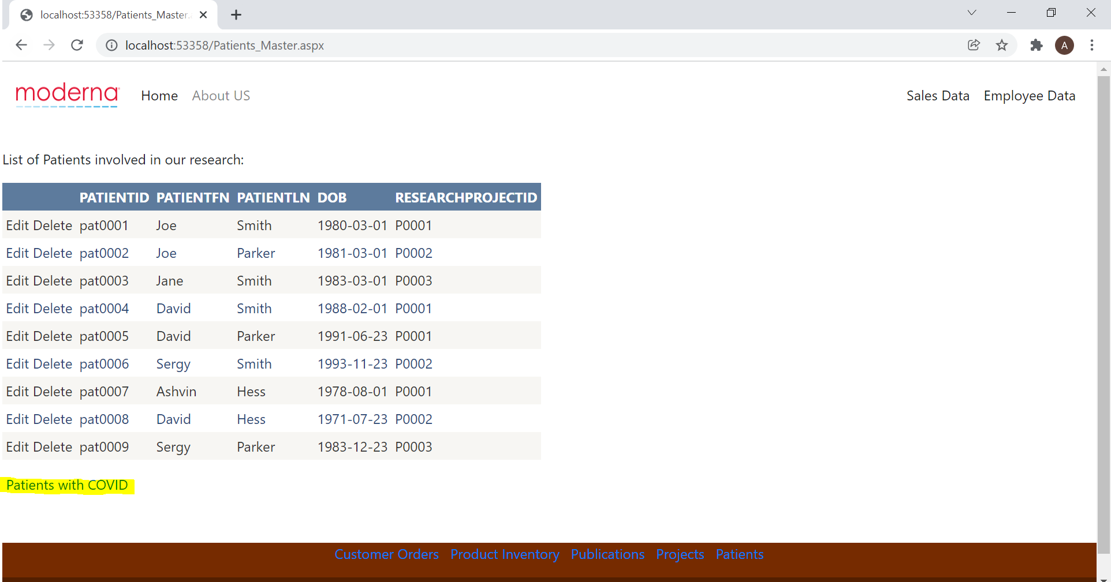

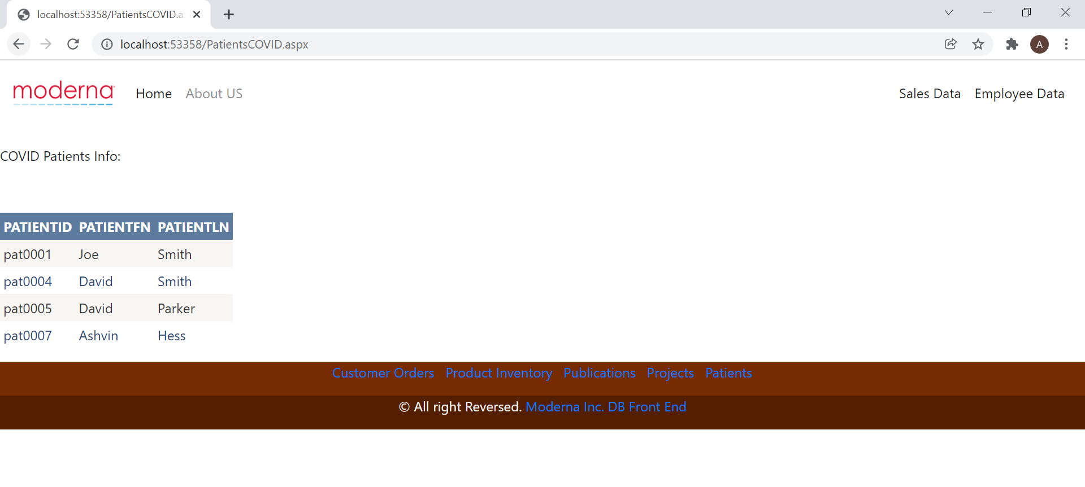

Data Insertion:

1. Employees Table:

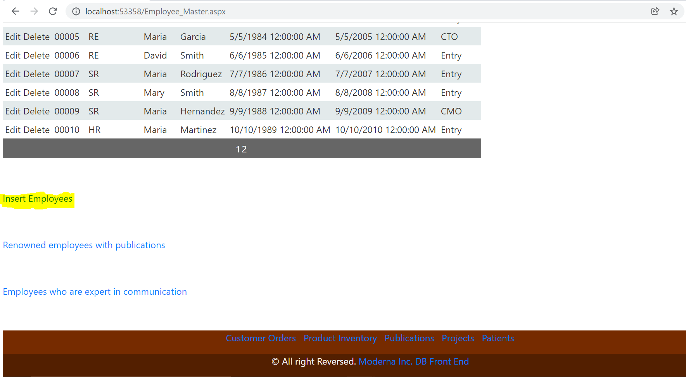

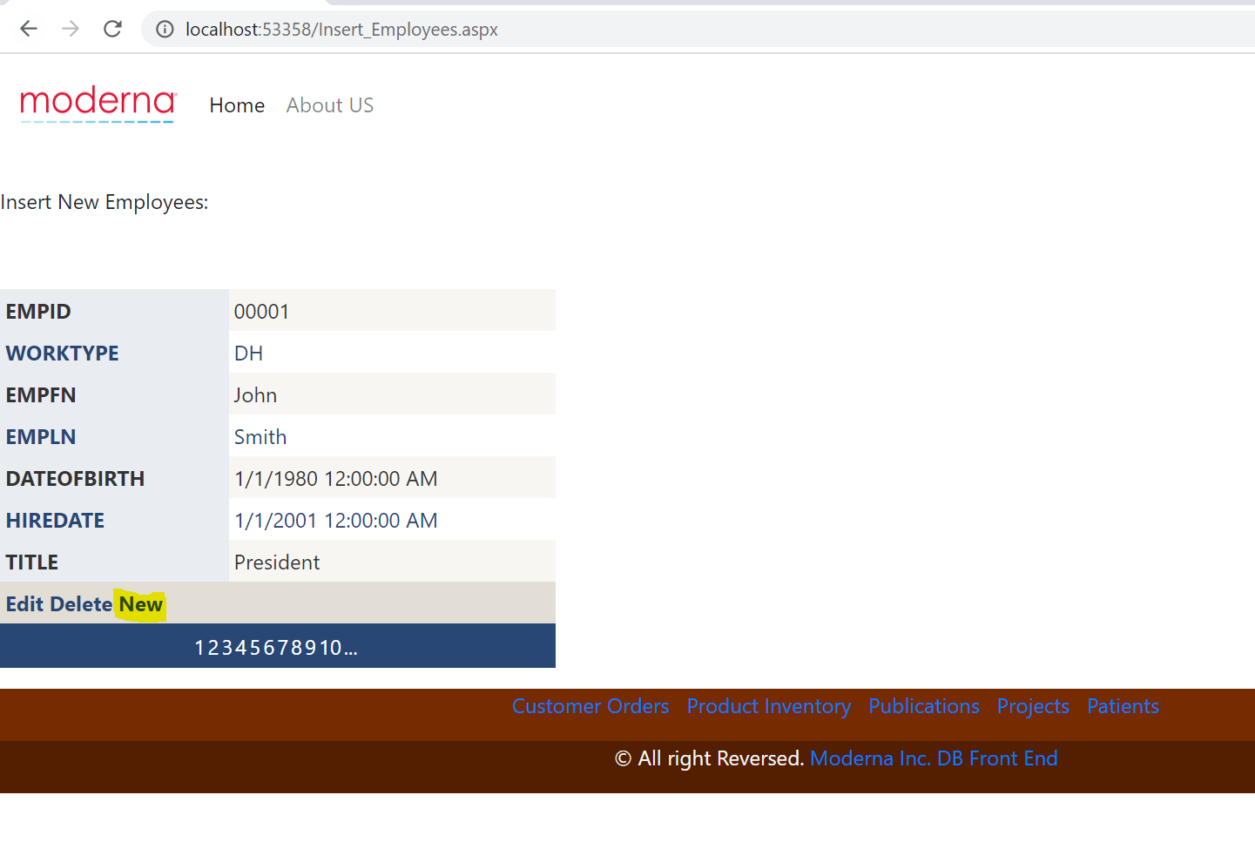

1. Insert Publications

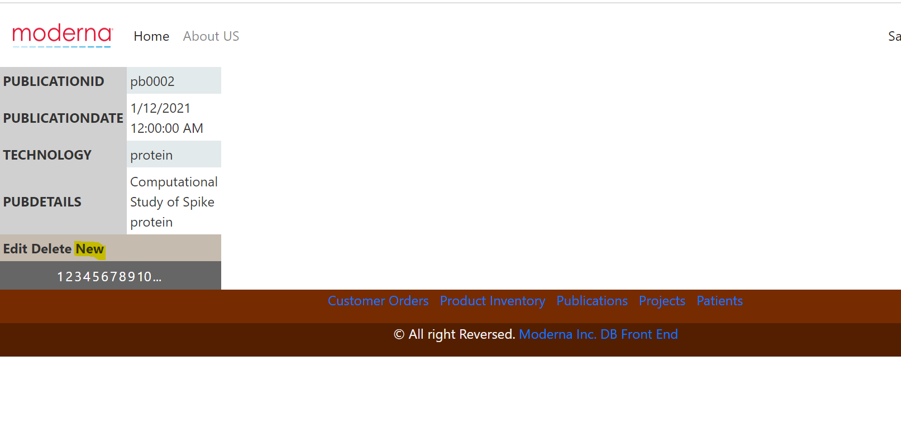

1. Insert New Patients

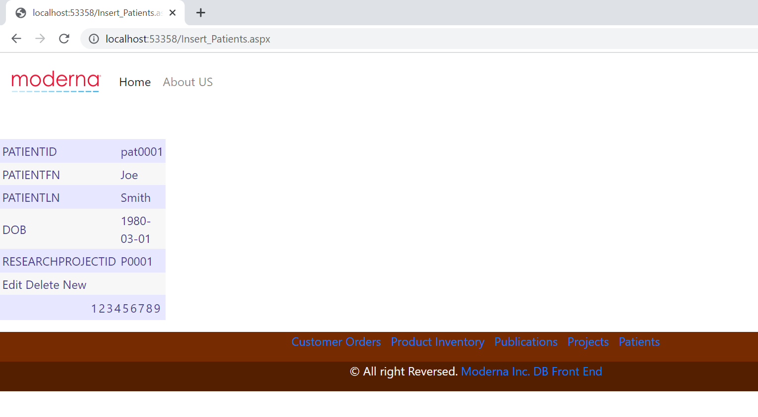

Chapter 7: Implementation Plan

1. Cloud Provider

We plan to utilize the Amazon Relational Database Service (RDS) as the remote cloud. The price for the Standard Edition Two (SE2), Memory Optimized Instances - Current Generation, db.r5.4xlarge of Oracle database is $7.712 per hour according to the price on their website. The cost of cloud provider for one year is 24 * 365 * 7.712 = $67,557.12.

1. Person-Hours and Costs

We need one person for requirement analysis, one person for conceptual database design, one person for logical DB design, three people for physical database design (SQL query, procedure/trigger, UI). Therefore, we need 6 people in total. The cost/salary for one person in one year is $150,000. Hence, the total cost is $150,000 * 6 = $900,000.

1. Hardware Costs

The configured computer for each of the 6 people costs about $8,000. So the total cost is $8,000 * 6 = $48,000.

In summary, the estimated cost for the implementation of the project in **one year** is $1,015,557.12.

|  |  |
| --- | --- |
| Number of employees | 6 |
| Cloud provider cost in one year | $ 67,557.12 |
| Person cost in one year | $900,000 |
| Hardware cost | $48,000 |
| Total cost in one year | $1,015,557.12 |

Appendix A: Lessons Learned

 During this project, we have learned several lessons. They are listed as follows:

1. The first and most important lesson we learned is that we need to start as early as possible and finish each milestone on time. The reason is that at the end of each semester, there are a lot of things to do. Besides, there may be some unexpected things during the accomplishment of the project.
2. The tasks need to be assigned clearly to each group member as well as the finish time.
3. Communication is also important. It is important to identify and solve the problems through sufficient communication.